|  |  |
| --- | --- |
|  | **FPT ACADEMY INTERNATIONAL**  **FPT – APTECH COMPUTER EDUCATION** |

**Centre Name: ACE-THUDUC-1-FPT.**

**Address: 21 Bis Hau Giang Street, Tan Son Nhat Ward, Ho Chi Minh City.**

**Java Florist**

**Design Document**

|  |  |  |
| --- | --- | --- |
| **Supervisor:** | Mr. Hoang Duc Quang | |
| **Semester:** | 3 | |
| **Batch No:** | T1.2406.E1 | |
| **Group No:** | 1 | |
| **Order:** | **Full name** | **Roll No.** |
| 1. | |  | | --- | | **Trần Trung Anh** | |  | | **Student1571996** |
| 2. | |  | | --- | | **Đặng Quốc Khánh** | |  | | **Student1572003** |
| 3. | |  | | --- | | **Lê Nguyễn Gia Huy** | |  | | **Student1571995** |
| 4. | |  | | --- | | **Thân Thế Lộc** | |  | | **Student1571994** |
| 5. | **Vũ Thị Hoài Thu** | **Student1571993** |

November 2025

Catalog

REVIEW 1 5

I. Acknowledgement 6

II. Problem Definition 7

1. Introduction: 7

III. Requirement Specification 7

1.Specifications Customer’s Requirement Specifications for Flower Delivery Website 7

1.1. Website: 7

1.2. Users: 8

1.3. Registered Users: 8

1.4. Admin: 9

2. Functional Requirement Specifications. 9

2.1. Function of User: 9

2.2. Function of Admin: 10

3. Function of Florist (Partner) 10

4. System requirement specifications 11

4.1. Server requirements: 11

4.2. Client Requirement 12

4.3. Development Software 12

4.4. Technology 12

TASK SHEET REVIEW 1 13

REVIEW 2 14

I. USE-CASE-DIAGRAM 15

1. Authentication & Account Management User 16

2. Catalog Browsing & Content Management 17

3. Shopping Cart Management 18

4. Purchase Transaction & Delivery 19

5. Partner Product 20

6. Product & Price Management (Admin) 21

7. Order & System Content Management (Admin) 22

8. Partner Management (Admin) 23

II. Sequence diagram 24

1. Sequence Diagram – User Registration 25

2. Sequence Diagram – Add to Cart 26

3. Sequence Diagram – Payment Processing (Credit Card) 27

4. Sequence Diagram – Delivery Scheduling Logic (5 hour/ day ) 28

5. Sequence Diagram – Admin Update/Delete Bouquet 29

III. Class diagram 30

IV. Data Flow Diagram (DFD) 31

1. Context Level Diagram 31

2. Level 0 DFD 32

3. Level 1 DFD- Full Diagram 33

4. Level 2 DFD - FULL DETAIL FOR ALL PROCESSES 34

4.1 DFD Level 2 — 1.0 Account Management 34

4.2 DFD Level 2 — 2.0 Bouquet Selection 35

4.3 DFD Level 2 — 3.0 Cart Management 36

4.4 DFD Level 2 — 4.0 Payment Processing 37

4.5 DFD Level 2 — 5.0 Order & Delivery Scheduling 38

4.6 DFD Level 2 — 6.0 Admin Management 39

V. Entity Relationship Diagram(ERD) 40

VI. Databse Diagram 41

1. Database design diagram 41

2. Database Structure 42

2.1 Table: User 42

2.2 Table: Customers 42

2.3 Table: Partners 43

2.4 Table: Occasions 43

2.5 Table: Messages 43

2.6 Table: Bouquets 44

2.7 Table: Bouquets_img 44

2.8 Table: CartItems 44

2.9 Table: Orders 45

2.10 Table: OrderDetails 45

2.11 Table: PayPalTransactions 46

2.12 Table: Payments 47

TASK SHEET REVIEW 2 48

Source 48

REVIEW 3 49

I. Technology 49

II. SiteMap 50

1. User site map 50

2. Admin site map 51

3. Florist site map 52

III. Gui Design-User Interface 53

1. User Interface 53

1.1 Home Page 53

1.2 Collection Page 55

1.3 About Page 56

1.4 Why Us Page 57

1.5 Partner Registion Page 58

1.6 Register Page 59

1.7 Login Page 60

1.8 My Acount Page 61

1.9 Your Profile 62

1.10 Change Password 63

1.11 All-products 64

1.13 Bouquet Detail Page 66

1.14 Card Page 67

1.15 Check Out Page 68

1.16 PayPal Page 69

1.17 My Order Page 70

1.18 Your profile 71

1.19 User change password 73

2. Partner 74

2.1 Partner Registration 74

2.2 Parter page 75

2.3 Parter Profile 76

2.4 Partner Order Management 78

2.5 Partner Analytics & Income 79

3. Admin Page 80

3.1 User Management 81

3.2 Bouquet Management 82

3.3 Pending Partner Applications 83

3.5 Admin Order Management 84

3.6 Admin Order Management Detaile 85

TASK SHEET REVIEW 3 87

# REVIEW 1

## Acknowledgement

First, we would like to express our gratitude to our dedicated instructor – Mr.Hoang Duc Quang. We would have not been able to finish this dissertation without his guidance and encouragement. During the time of the project, he continuously gave us constructive advises and showed his passion in teaching to help us reach the expected result of the projects. Therefore, we truly value his dedication and we learned a lot from him.

Next, we fully appreciate our team members who worked day and night to carry out and complete this project. Although sometimes there were challenges, but by through them, we learned a lot and our team bonds became stronger. The project is the result of our relentless efforts to improve through every step, our strong commitment to the expected outcome and our passionate spirit at one team.

Finally, we would send a huge thanks to Aptech’s eProject team who gave us an excellent chance to apply what we have learnt theoretically into real products and gain experience as well as innovative mindset which is extremely vital for our future career and our end users.

## Problem Definition

### Introduction:

One way of expressing love, joy, or sympathy is through the gift of flowers. Our client Java Florist owns a well-known flower shop that is famous for its fresh and beautifully designed flower arrangements.

As the number of customers and delivery orders has grown rapidly, Java Florist has decided to develop a website to expand its business reach and provide online flower delivery services.

Through the website, customers will be able to:

* View and order flower bouquets for various occasions.
* Register to become regular customers for exclusive offers.
* Purchase special floral design books written by Java Florist.
* Submit their own flower arrangement ideas, and if selected by the admin, receive prize money, a certificate, and be featured on the homepage under Top Floral Designs.

## Requirement Specification

### 1.Specifications Customer’s Requirement Specifications for Flower Delivery Website

#### 1.1. Website:

* Home Page: Contains menus like Home, Login/Register, Browse Flowers by Occasion, Contact Us, About Us, FAQ, Cart, My Account, Florist Registration. Display sections for top occasions (e.g., Birthday, Wedding, Thank You) with featured bouquets, images, and prices. Show promotional banners for same-day delivery in Mumbai and nationwide options.
* Feedback Form: Allows feedback from both registered and unregistered users. Includes fields for name, email, rating, comments, and submission.
* Online Order: List of bouquets with images, descriptions, prices, and "Add to Cart" buttons. Users can browse by occasions; clicking an occasion shows relevant bouquets. Cart functionality to add multiple items, view total, edit quantities, or remove items. Checkout requires authentication (login or register), collects recipient details (name, address, phone, message), and processes payment via credit/debit card. After payment, display confirmation message with order status and scheduled delivery time.
* About Us: Describes the flower shop, its history, owner, and network for nationwide delivery.
* Contact Us: Displays contact details including address, phone, email, and a map for Mumbai location.
* Occasion Pages: Dedicated pages or sections for each occasion (e.g., Birthday, Wedding), listing bouquets with filters for price, color, or type.
* Product Detail Page: For each bouquet, show detailed description, multiple images, price, availability, related occasions, and "Add to Cart" option with quantity selector.
* Cart Page: Shows added items, quantities, subtotals, total amount, and options to proceed to checkout or continue shopping.
* Checkout Page: Collects payment details (credit/debit card with validation), recipient info (name, address, phone), occasion dropdown to select pre-defined message templates or custom message (textarea with character limit, e.g., 200). Applies delivery rules and calculates scheduled delivery time.
* My Account Page: For registered users, includes profile editing, order history with status updates, and past deliveries.
* Florist Registration Page: Form for florists to register as partners, providing name, contact info, location, and approval status.

#### 1.2. Users:

* Registration Page: Users register with name, email, password, phone. No payment required for basic registration, but login is mandatory for placing orders. Florists have a separate registration for partnership.
* General Access: Unregistered users can browse occasions, view bouquets, read about us, contact, and provide feedback. They can add to cart but must register/login to checkout.
* Ordering Bouquets: Users (registered or after quick registration during checkout) can order multiple bouquets in one go via cart. Provide recipient details, select or custom message, and pay online. Delivery within Mumbai (same-day if rules met) or nationwide via network.
* Message Customization: After payment, select occasion from dropdown to view template messages; option to write custom message.
* Delivery Rules: Orders placed during working hours (9:00–21:00) with at least 5 hours remaining deliver same day (placed time + 5 hours). Otherwise, schedule for next day starting at 9:00 plus remaining time. Handle edge cases like late-night orders or near closing.

#### 1.3. Registered Users:

* All previous functions enabled after login with username/password.
* Access to My Account for profile management and order history.
* View personalized recommendations based on past orders or occasions.
* Ability to track order status (e.g., Pending, Confirmed, Out for Delivery, Delivered).
* Florist Role (after approval): Access to dashboard for viewing assigned orders, updating delivery status, and managing partnerships.

#### 1.4. Admin:

Admin has a separate login page with the following functions:

* Manage bouquets: Add, update, delete bouquets including title, description, price, images, occasions, quantity, and active status.
* View and manage user registrations, including roles (user, florist).
* Check order list, update statuses (e.g., from Pending to Delivered), view recipient details, and handle refunds if needed.
* Review feedbacks from users.
* Manage florist registrations: Approve/reject, assign orders for nationwide delivery.
* View reports on orders by date, occasion, or total sales.
* Configure message templates per occasion.

### 2. Functional Requirement Specifications.

#### 2.1. Function of User:

##### 2.1.1. Un-Registered Users:

REQ-01. Guests shall be able to register for a free account with name, email, password, and phone number. No payment required for registration.

REQ-02. Guests shall be able to order bouquets by providing recipient details and completing online credit/debit card payment

REQ-03. Guests shall browse all occasions and view associated bouquets.

REQ-04. Guests shall view the About Us page describing the flower shop and owner.

REQ-05. Guests shall submit feedback via a form (name, email, rating, comments).

REQ-06 Guests shall add bouquets to cart without login (session-based).

REQ-07. Guests shall access Contact Us and FAQs.

##### 2.1.2. Registered Users:

REQ-08. Registered users shall have all functions of un-registered users (REQ-01 to REQ-07).

REQ-09. Users shall login with email and password, and logout securely.

REQ-10. Users shall view personalized order history with tracking and delivery status.

REQ-11. My Profile: Users shall be able to:

• Change password

• Update saved payment method (masked card info)

  • View past orders with recipient details, message, and scheduled delivery time

#### 2.2. Function of Admin:

REQ-13. Admin shall login, logout, and change password via /admin panel

REQ-14. Admin shall manage bouquets: add, edit, delete, set price, upload images (up to 5), assign to occasions, set stock quantity, and toggle active status.

REQ-15 Admin shall view all orders with customer info, payment status, recipient details, and scheduled delivery.

REQ-16. Admin shall view all registered users, change their password, or delete accounts.

REQ-17 Admin shall view all feedback and delete inappropriate entries.

REQ-18. Admin shall manage occasions: add, edit, delete (e.g., Birthday, Wedding, Thank You).

REQ-19. Admin shall manage message templates per occasion: add, edit, delete.

REQ-20. Admin shall view and update order status.

### 3. Function of Florist (Partner)

REQ-21. Florists shall register via dedicated form: shop name, owner name, email, phone, address, service areas, business license (optional).

REQ-22. Registration status shall be Pending until admin approval.

REQ-23 Approved florists shall login to Partner Dashboard with email and password.

REQ-24. Partner Dashboard shall display:

• List of assigned orders (nationwide or Mumbai overflow)

  • Recipient name, address, phone, message, bouquet details

• Scheduled delivery time

REQ-25. Florists shall update delivery status:

• Picked Up → Out for Delivery → Delivered

  • System auto-notifies customer upon status change

REQ-26. Florists shall view earnings report (commission per delivered order).

### System requirement specifications

#### 4.1. Server requirements:

* Hardware:

|  |  |
| --- | --- |
| **Component** | **Requirement** |
| **CPU** | Processor type:  Pentium IV-compatible processor or faster  Processor speed:  Recommended: 2.0 GHz or faster |
| **OS** | Microsoft Windows XP or higher with IIS |
| **Memory (RAM)** | RAM:  Minimum: 512 MB  Recommended: 2 GB or more |
| **Hard Drive** | Free space:  Minimum: 200 MB  Recommended: 50 GB or more  Maximum: Operating system maximum |

* Software:

|  |  |
| --- | --- |
| **Component** | **Requirement** |
| **ASP.NET core web api** | Version .NET Core 9.0 |
| **RDBMS** | SQL Server |
| **REACT.JS** | React 18.3.1 |

#### 4.2. Client Requirement

* Hardware:

|  |  |
| --- | --- |
| **Component** | **Requirement** |
| **CPU** | Processor type:  Pentium III-compatible processor or faster  Processor speed:  Recommended: 1.0 GHz or faster |
| **OS** | All OS(Window ,Linux ,Android ,Mac OS …) |
| **Memory (RAM)** | RAM:  Minimum: 512 MB  Recommended: 1 GB or more  Maximum: Operating system maximum |
| **Hard Drive** | Free space:  Minimum: 10 MB |

* Software:

|  |  |
| --- | --- |
| **Component** | **Requirement** |
| **Web Browser** | Microsoft edge,Chrome or Higher….. |

#### 4.3. Development Software

* SQL Server.
* Microsoft Visual Studio 2022.

#### 4.4. Technology

* ASP.Net web core api 9.0
* Entity Framework Core 9.0

TASK SHEET REVIEW 1

|  |  |  |  |  |  |  |  |
| --- | --- | --- | --- | --- | --- | --- | --- |
| **Project Ref. No.:**  **eP/Advertisement** **Portal Management** **System/01** | | **Project Title:** | **Activity Plan** **Prepared** **By:** | **Date of Preparation of Activity Plan:** | | | |
| **St.No.** | **Task** | **Actual Start** **Date** | **Actual** **Days** | **Team** **Mate** **Names** | **Status** |
| 1 | Acknowledgement | Java Florist | Vu Thi Hoai Thu | 12/11/2025 | 1 | All member | Completed |
| 2 | Problem Definition | 12/11/2025 | 1 | All member | Completed |
| 3 | Requirement Specification | 12/11/2025 | 1 | All member | Completed |
| 4 | Task sheet review | 12/11/2025 | 1 | All member | Completed |

|  |  |
| --- | --- |
|  | |
| **Date: 12/11/2025** | |
| Signature of Instructor:  **Mr. Hoang Duc Quang** | Signature of Team Leader:  **Vu Thi Hoai Thu** |

# REVIEW 2

## USE-CASE-DIAGRAM

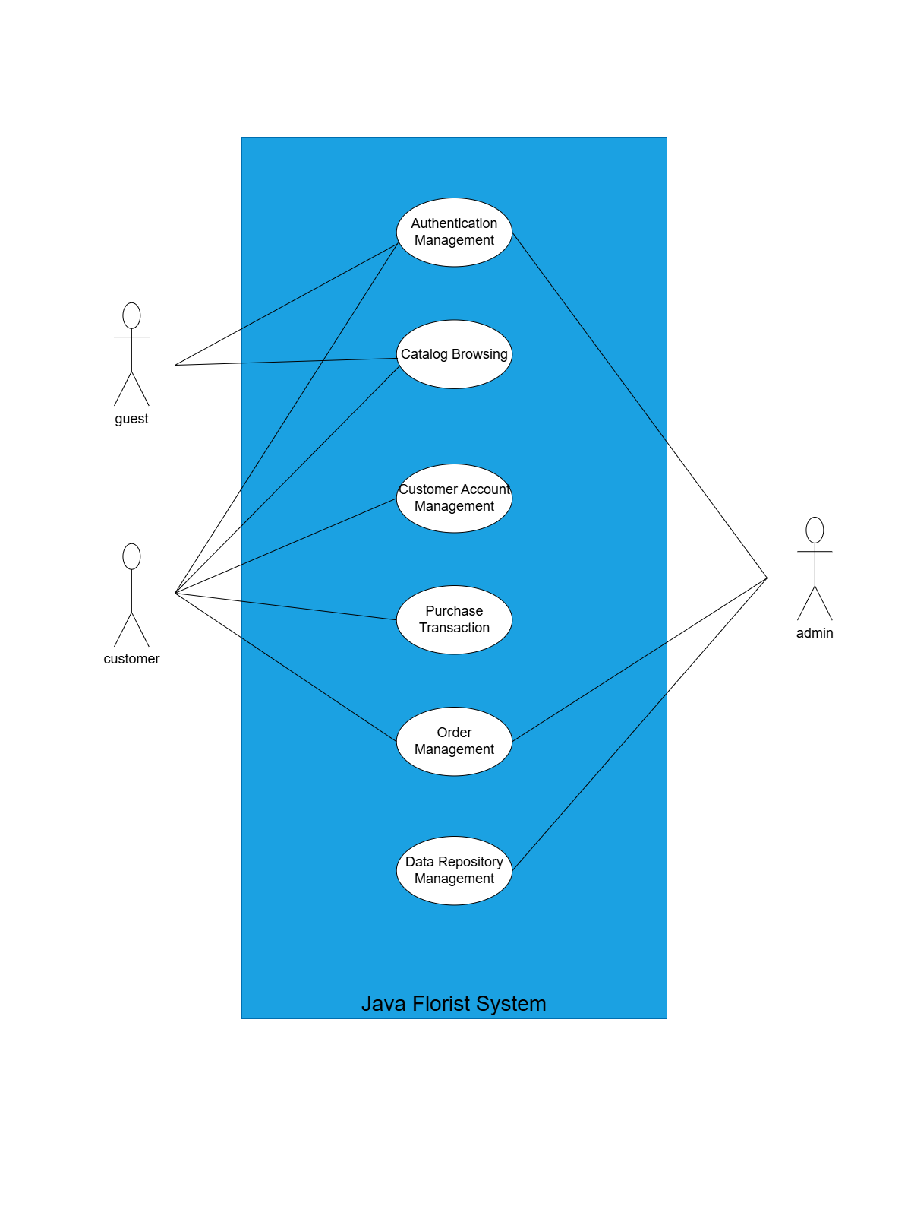

### Authentication & Account Management User

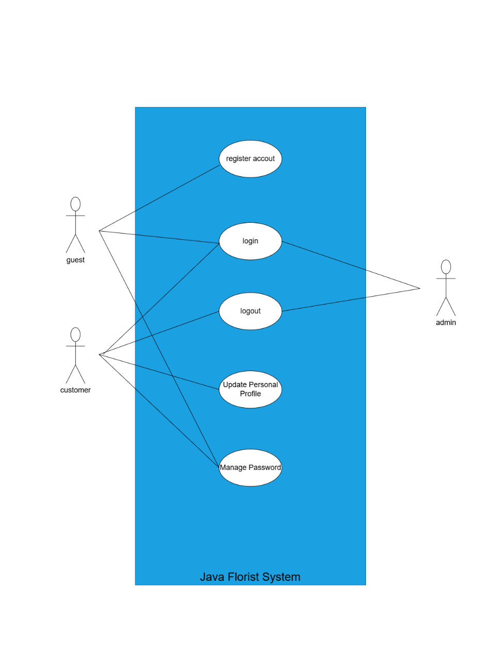

### 

### Catalog Browsing & Content Management

### Shopping Cart Management

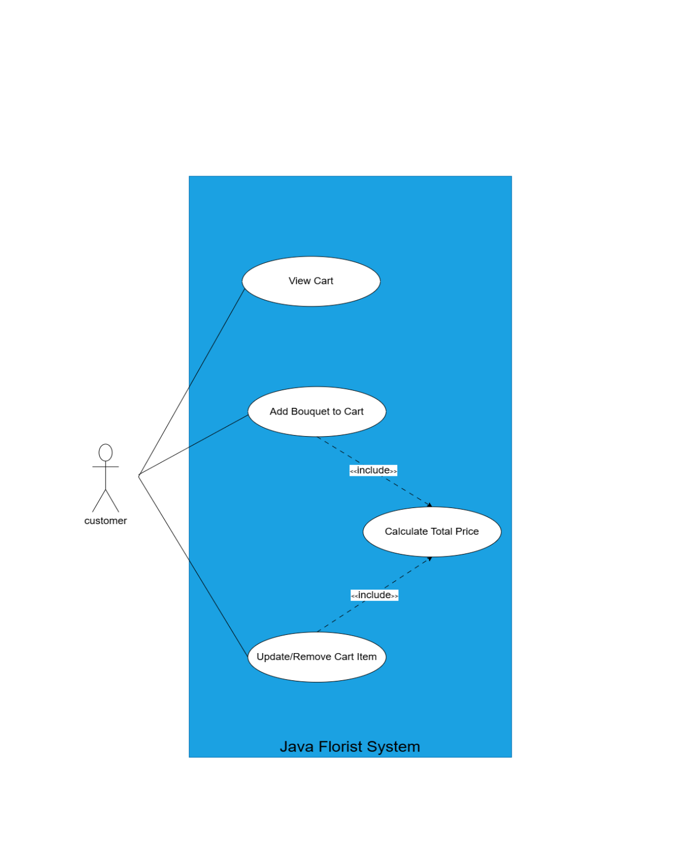

### Purchase Transaction & Delivery

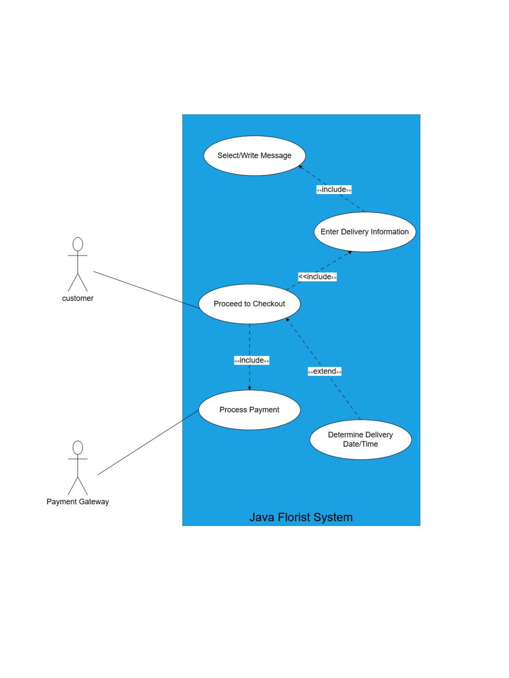

### Partner Product

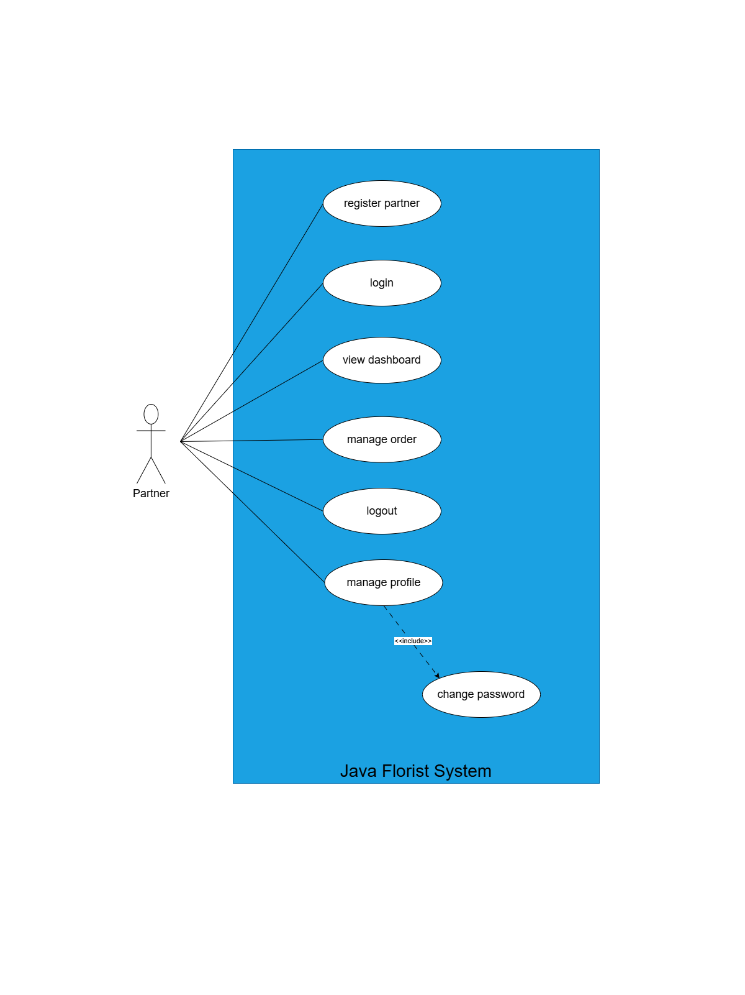

### Product & Price Management (Admin)

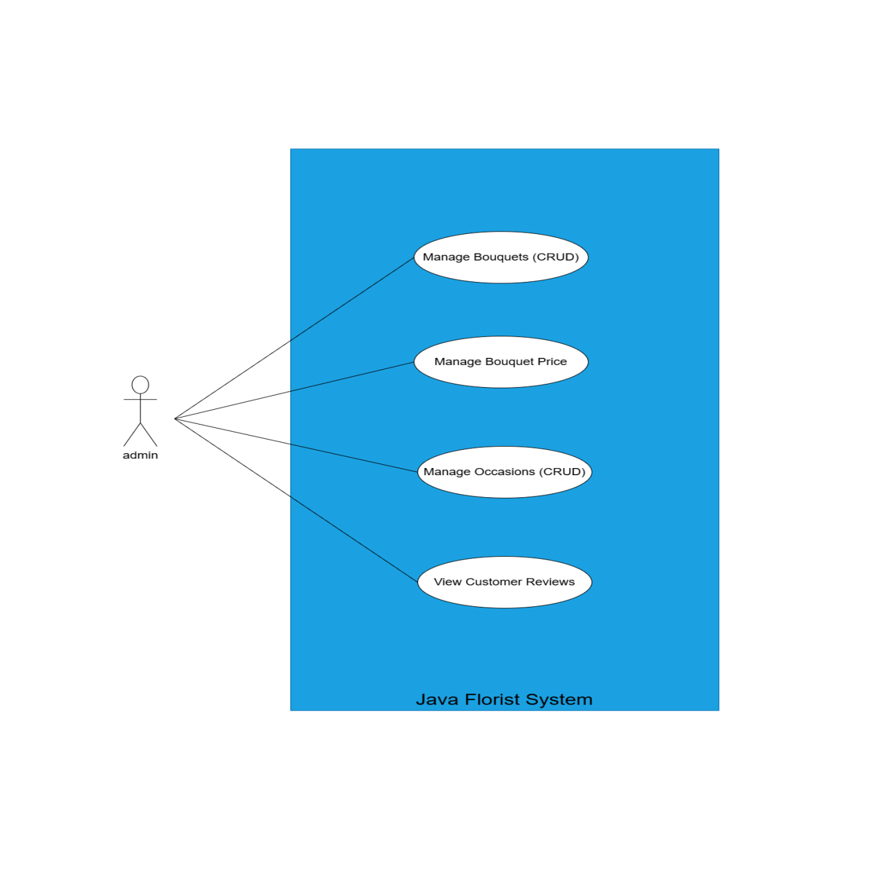

### Order & System Content Management (Admin)

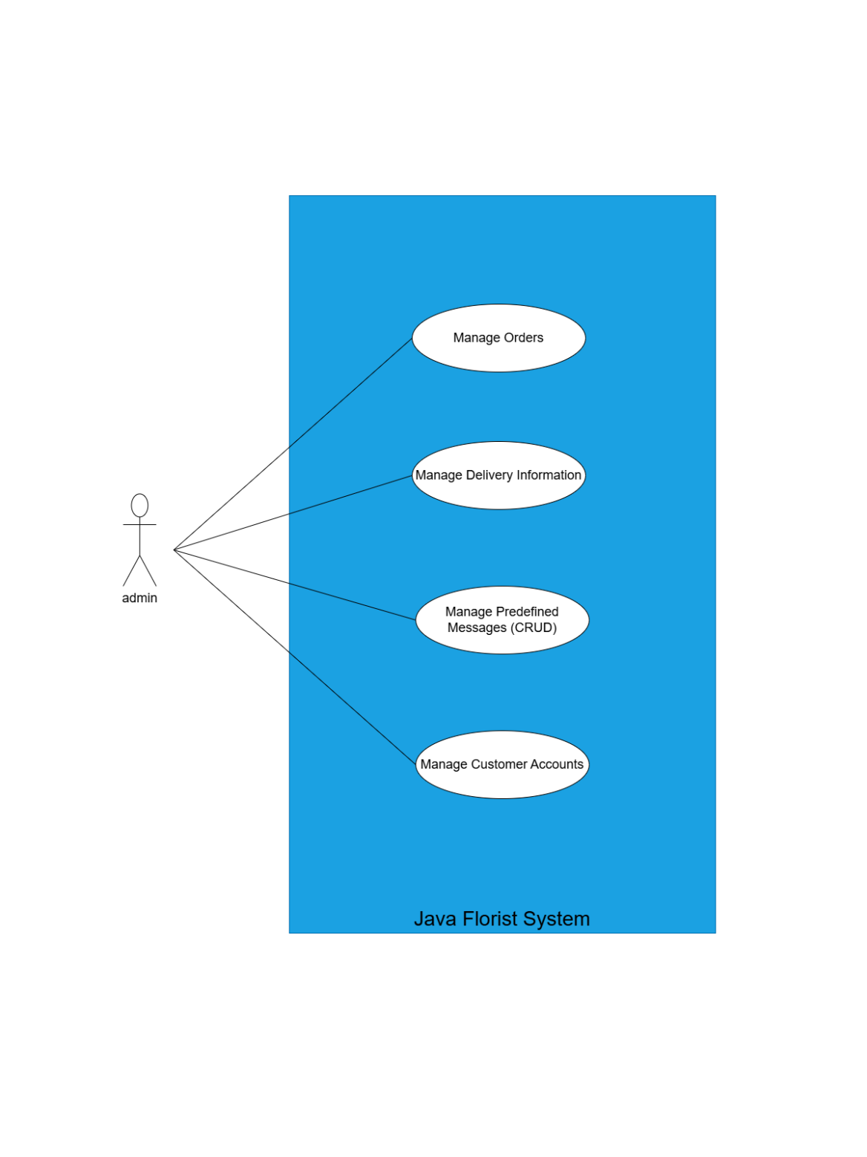

### Partner Management (Admin)

## 4

## Sequence diagram

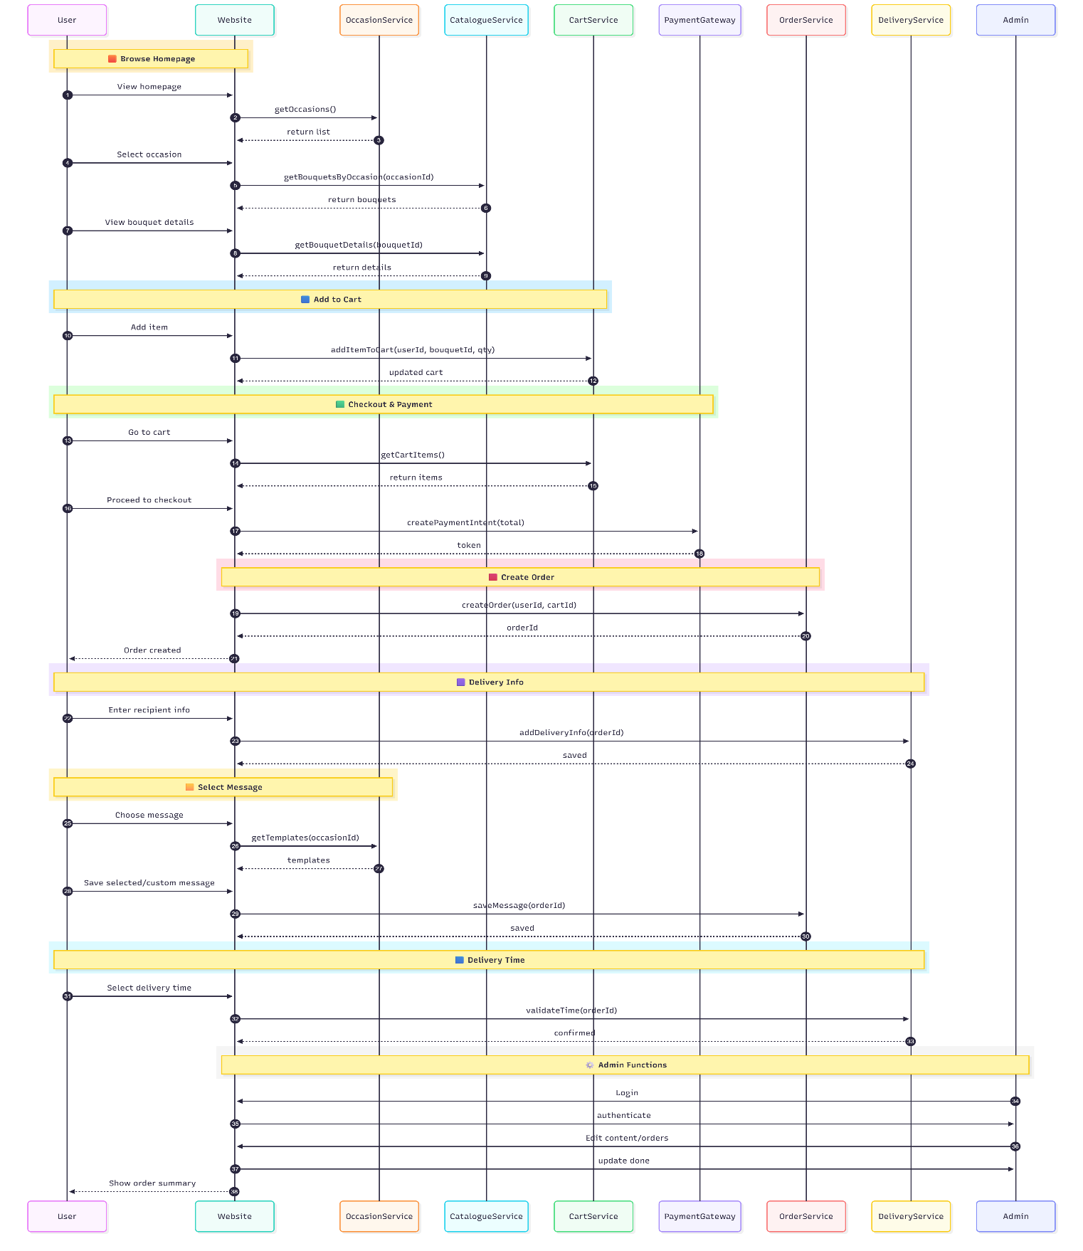

### Sequence Diagram – User Registration

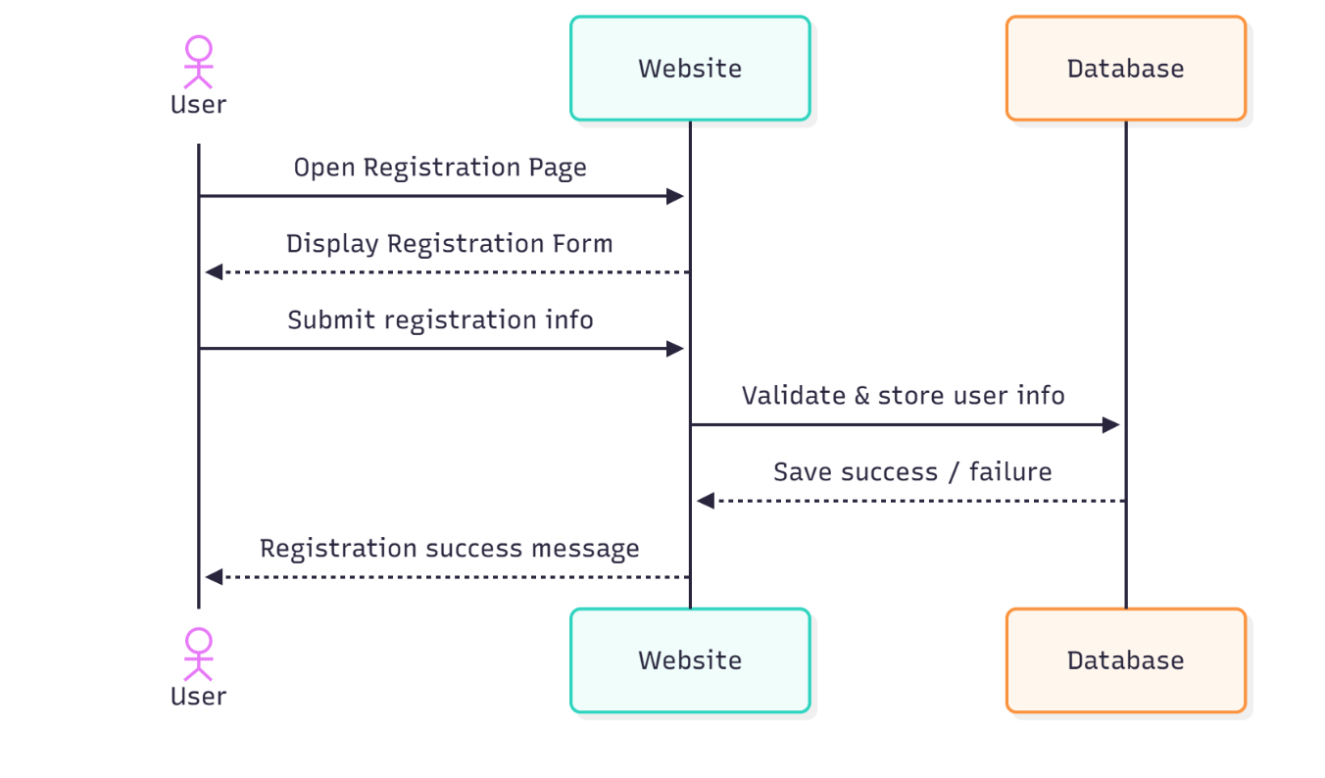

### Sequence Diagram – Add to Cart

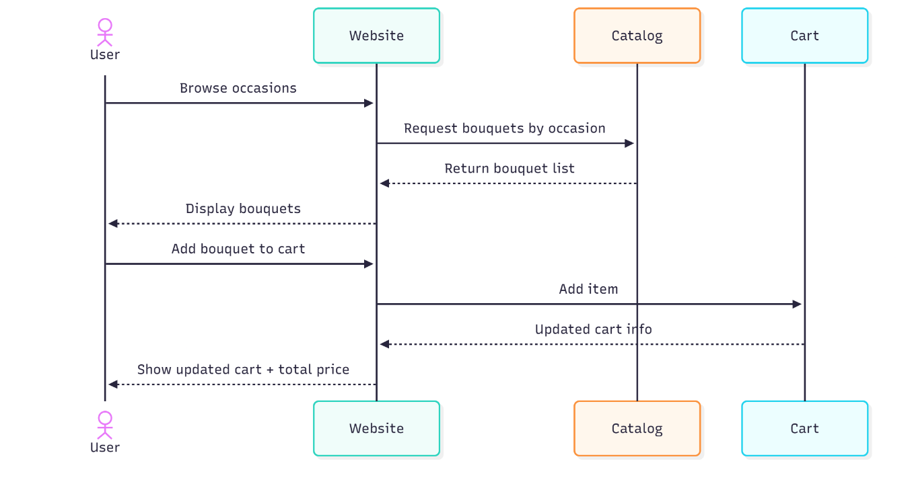

### Sequence Diagram – Payment Processing (Credit Card)

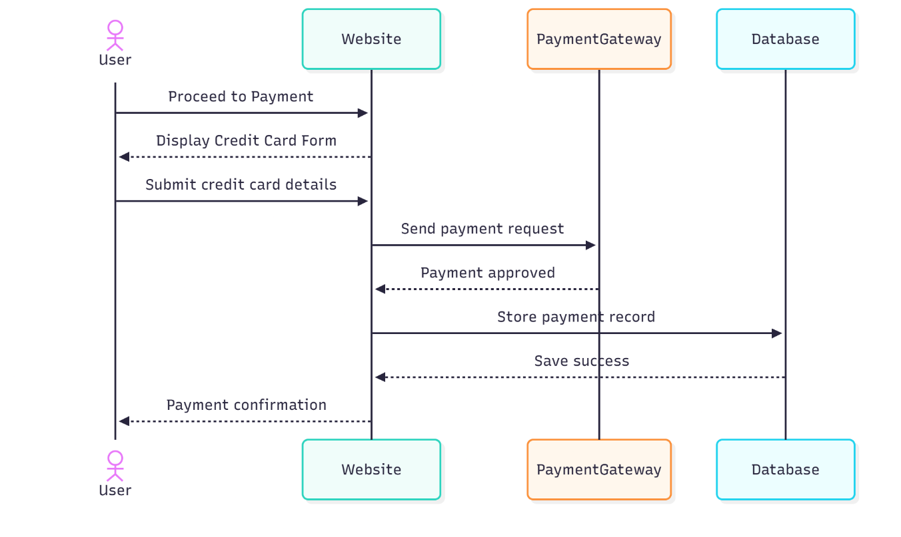

### Sequence Diagram – Delivery Scheduling Logic (5 hour/ day )

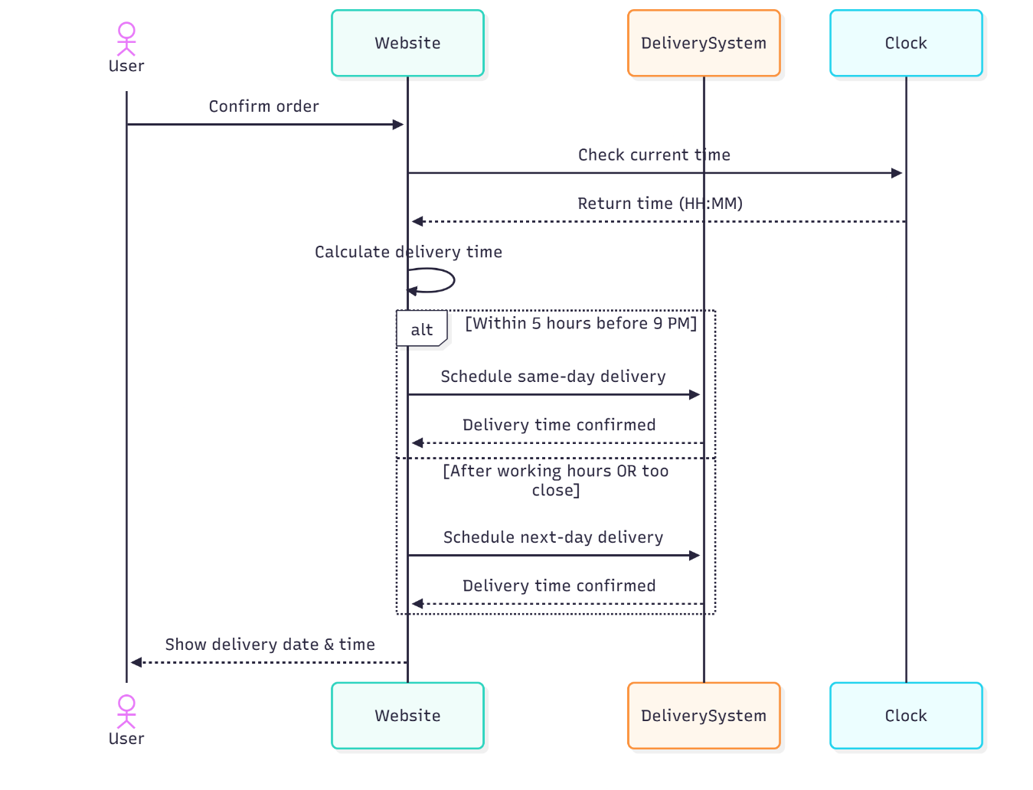

### Sequence Diagram – Admin Update/Delete Bouquet

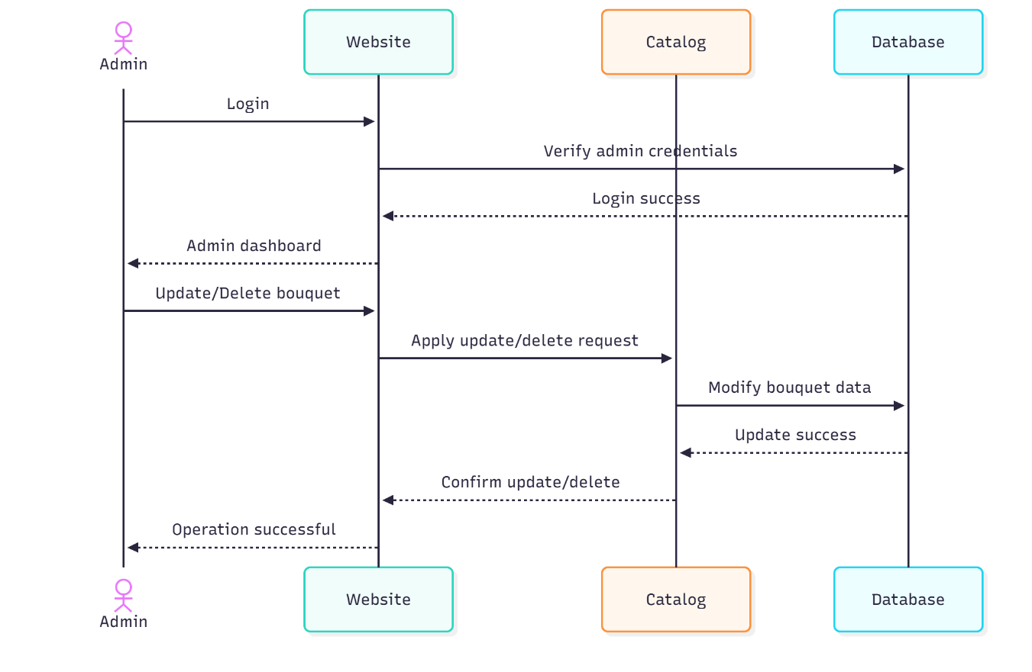

## Class diagram

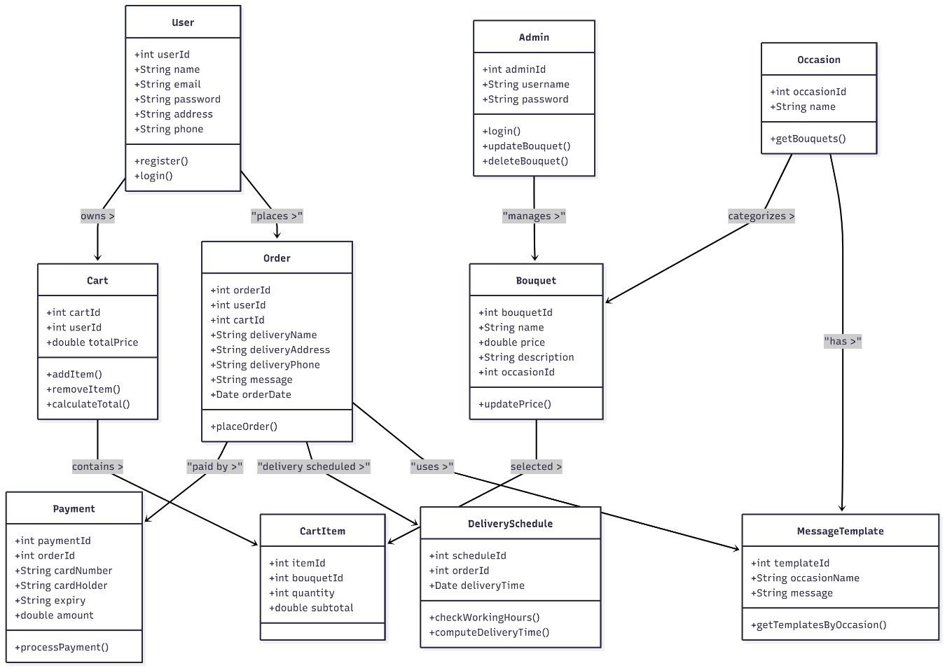

## Data Flow Diagram (DFD)

### Context Level Diagram

## 

### Level 0 DFD

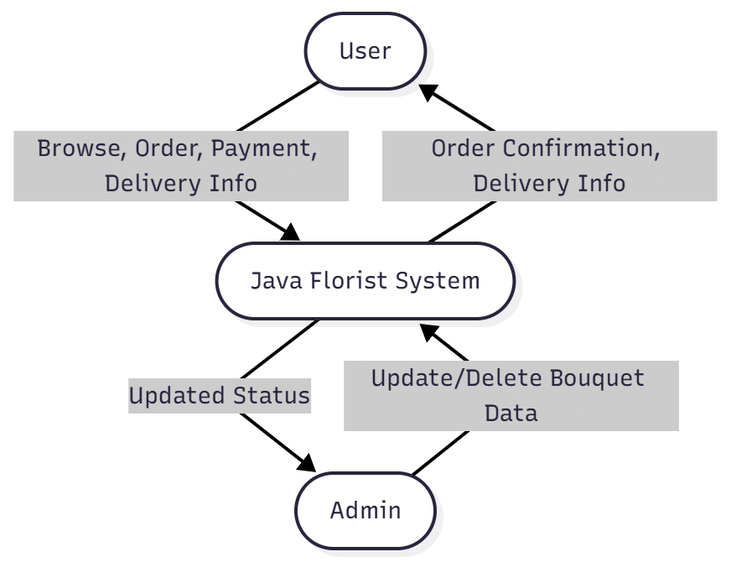

### Level 1 DFD- Full Diagram

### 

### Level 2 DFD - FULL DETAIL FOR ALL PROCESSES

#### 4.1 DFD Level 2 — 1.0 Account Management

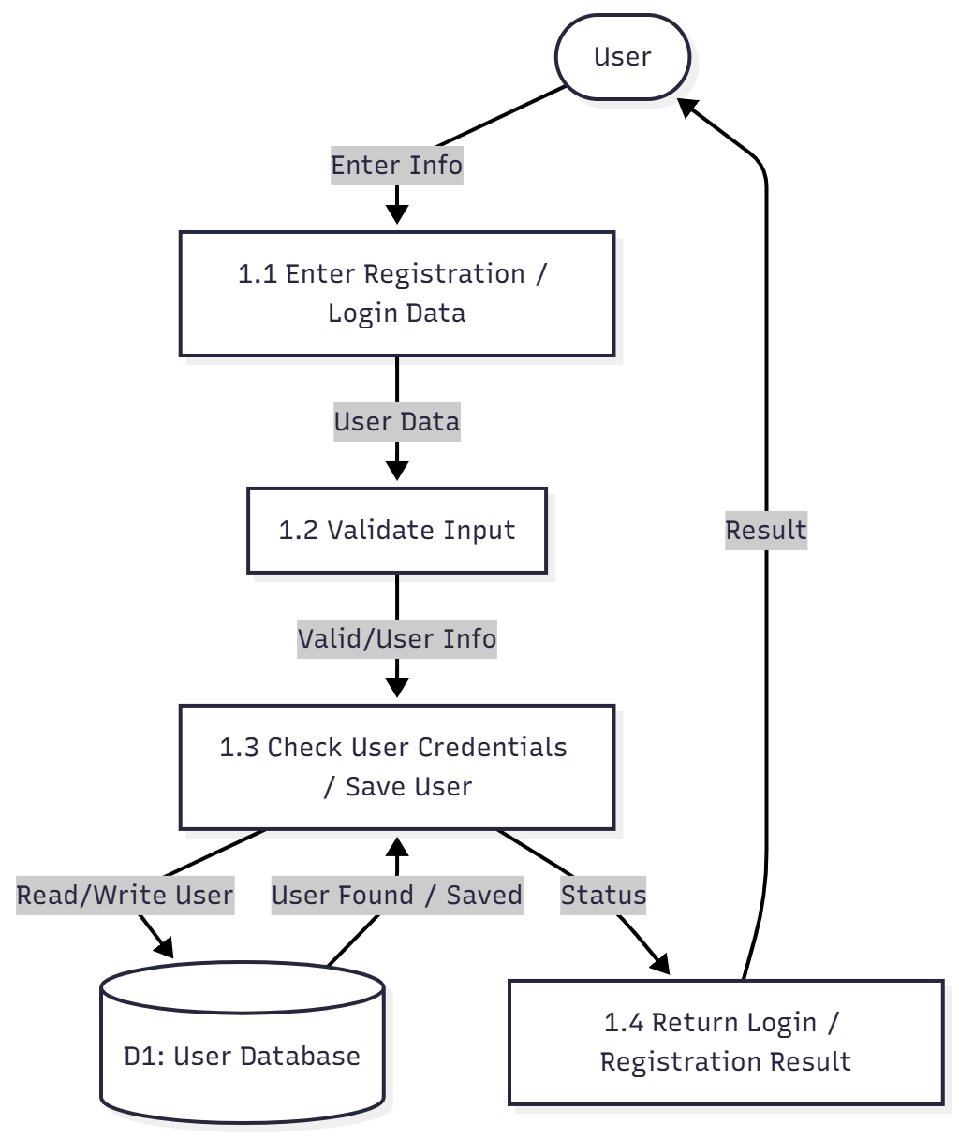

#### 4.2 DFD Level 2 — 2.0 Bouquet Selection

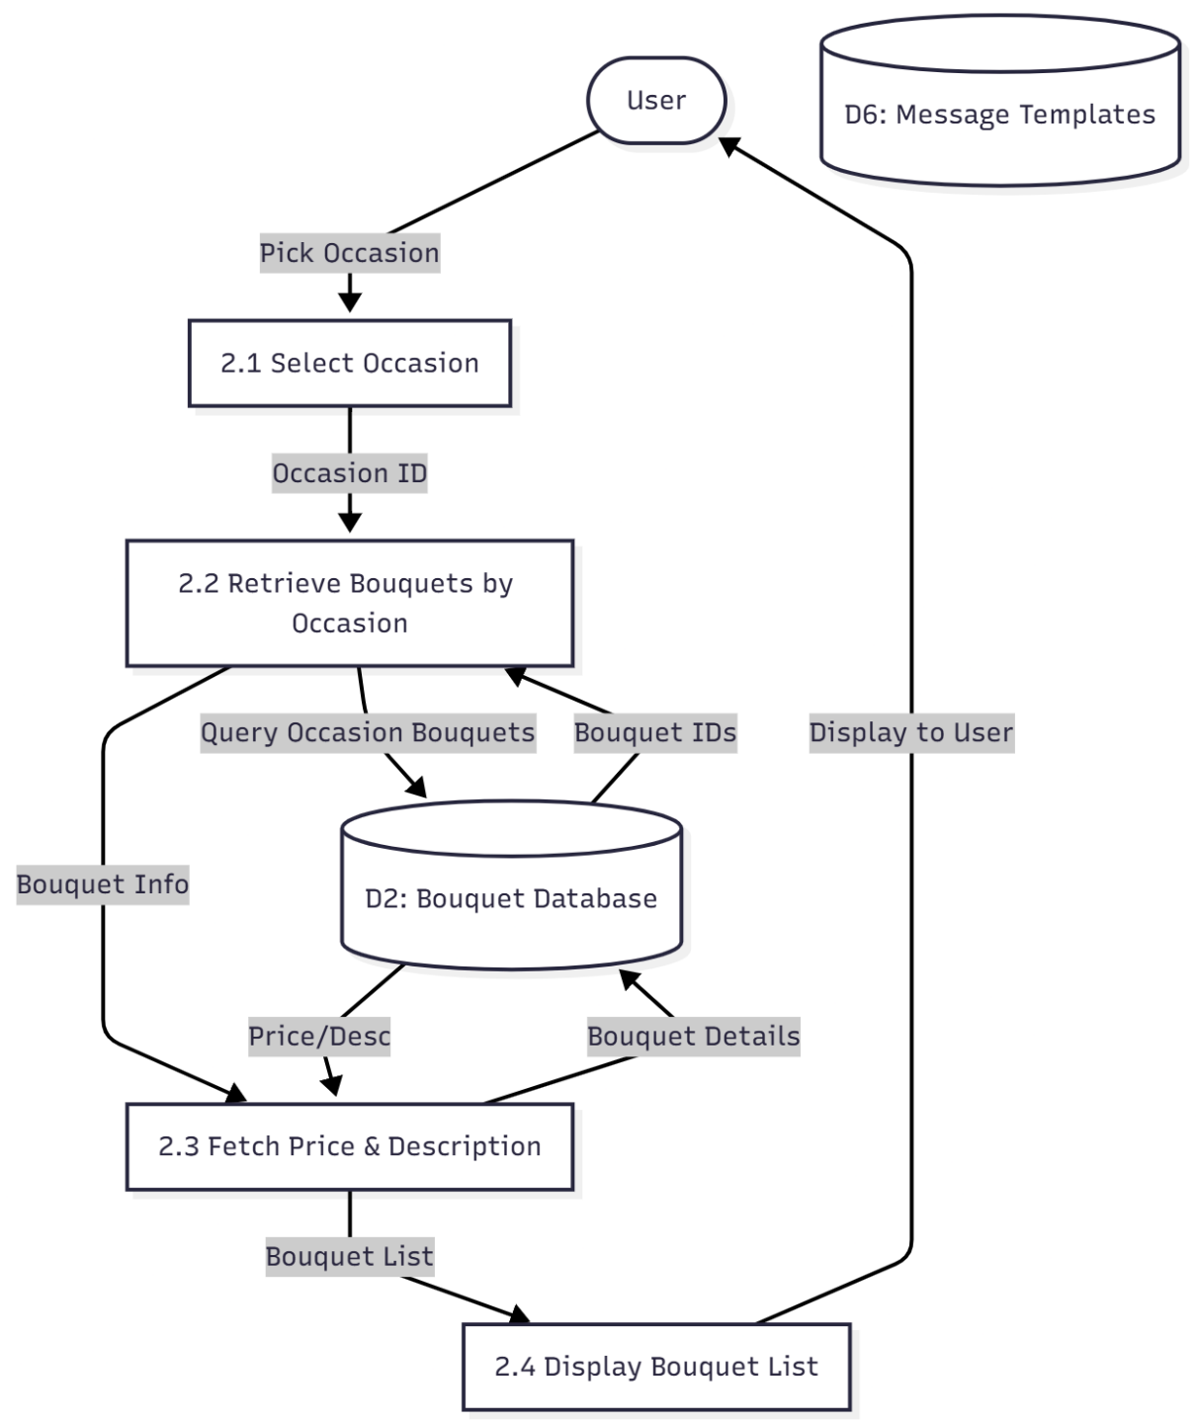

#### 4.3 DFD Level 2 — 3.0 Cart Management

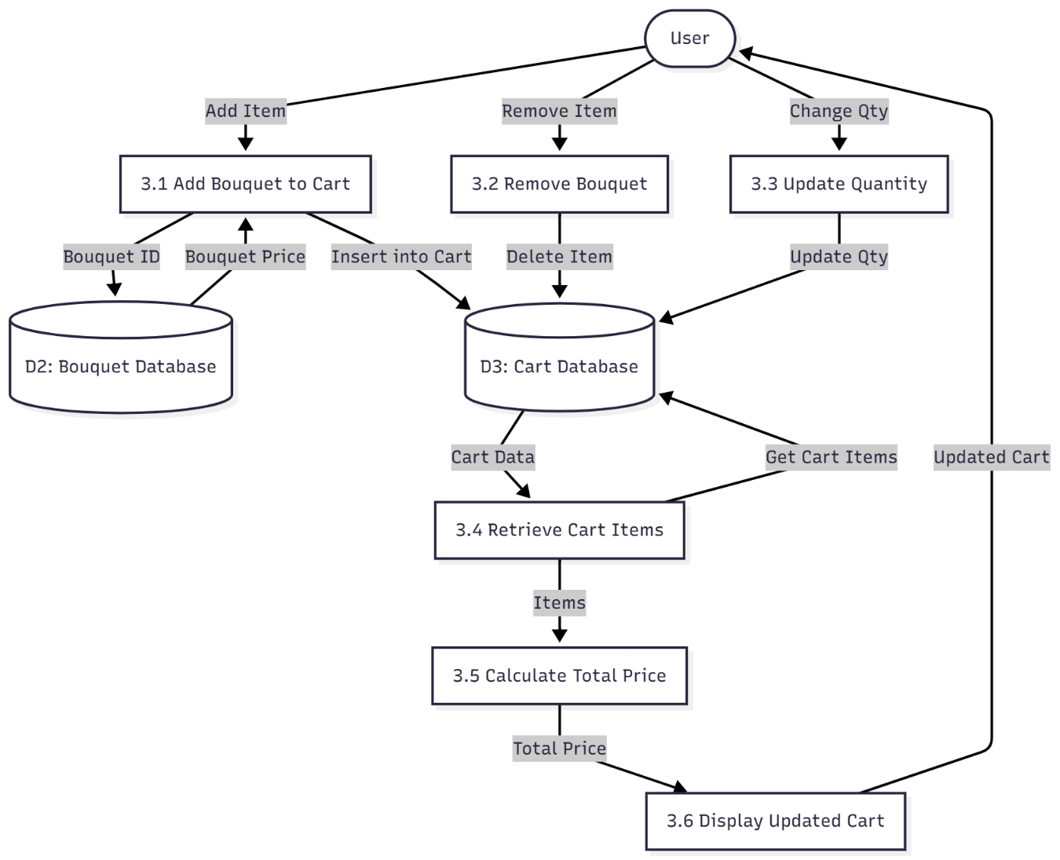

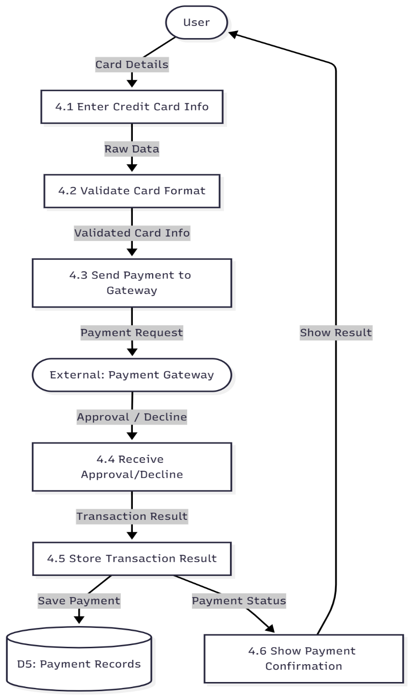

#### 4.4 DFD Level 2 — 4.0 Payment Processing

#### 4.5 DFD Level 2 — 5.0 Order & Delivery Scheduling

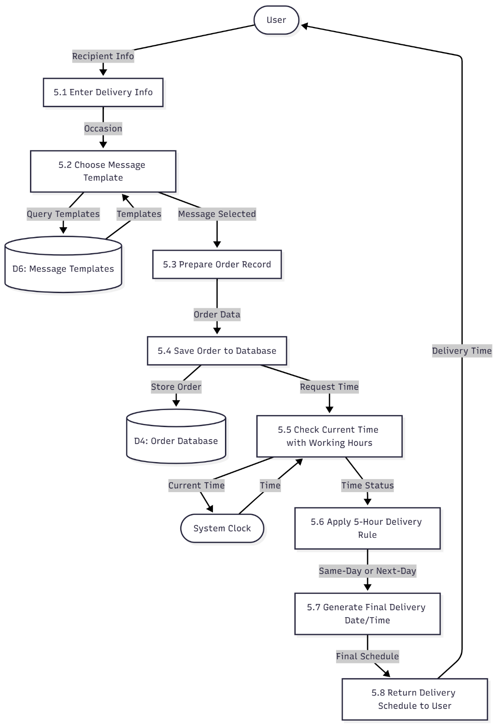

#### 4.6 DFD Level 2 — 6.0 Admin Management

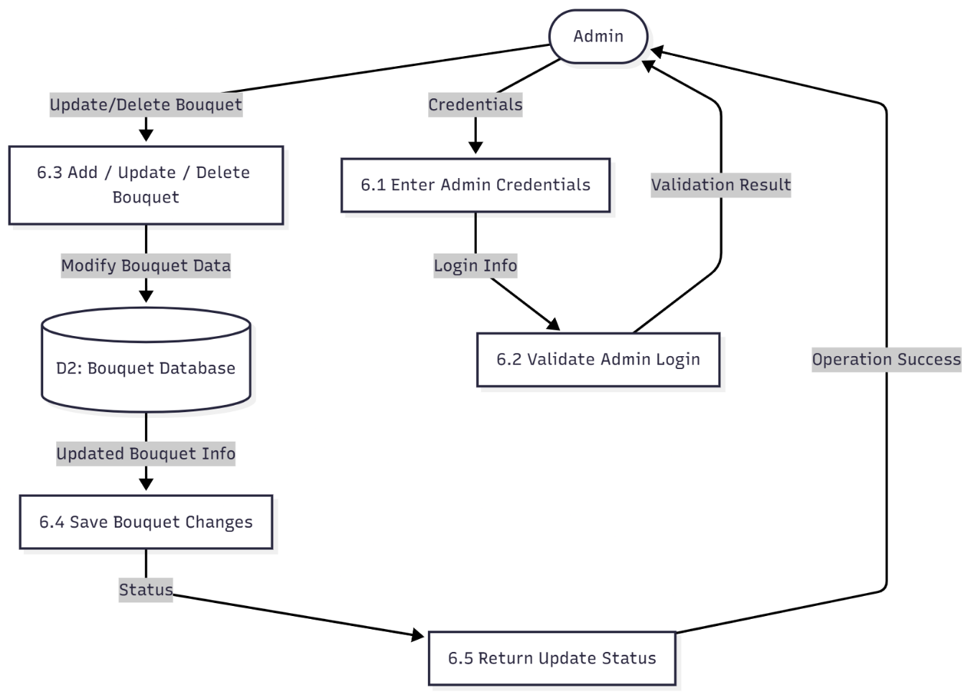

## Entity Relationship Diagram(ERD)

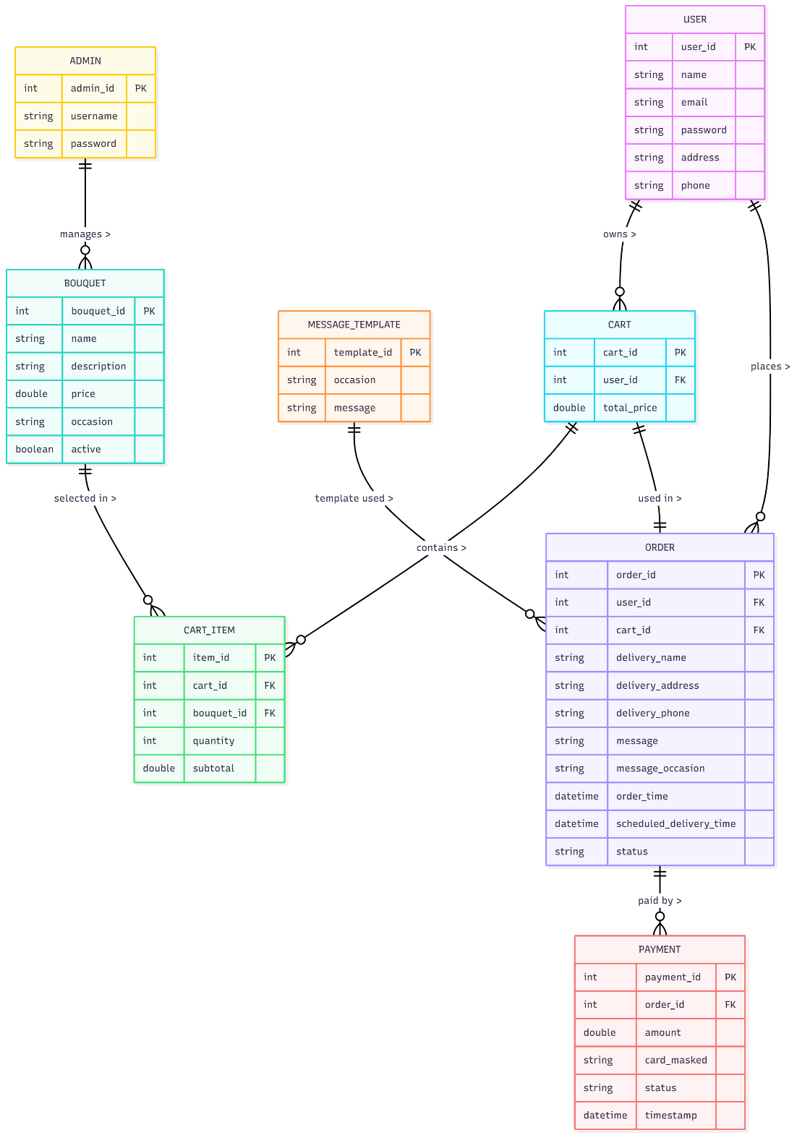

## Databse Diagram

### Database design diagram

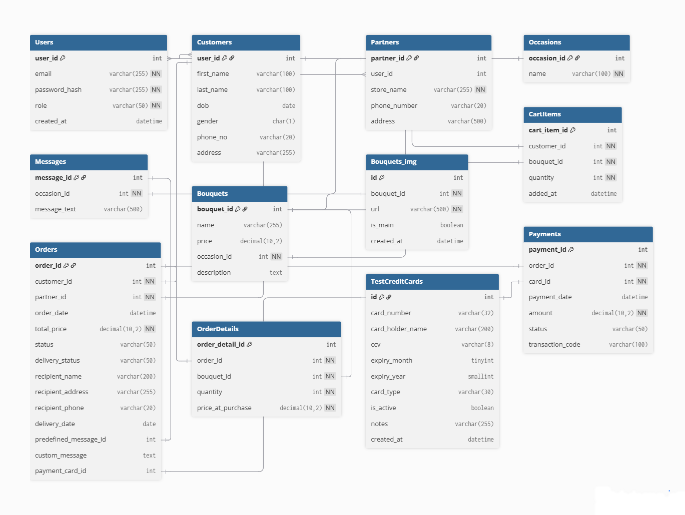

### Database Structure

#### 2.1 Table: User

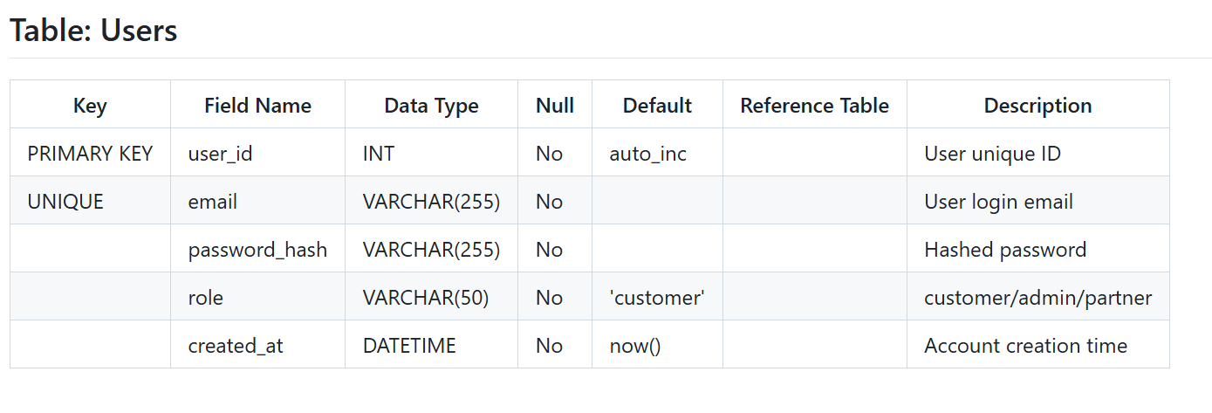

#### 2.2 Table: Customers

#### 2.3 Table: Partners

#### 2.4 Table: Occasions

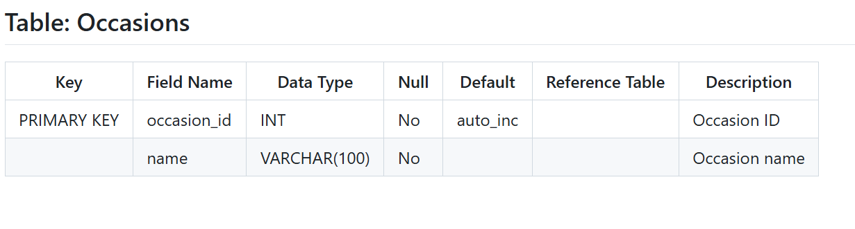

#### 2.5 Table: Messages

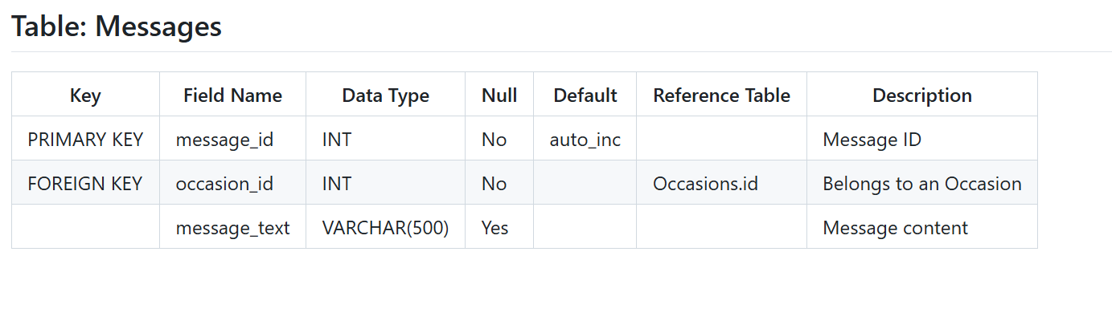

#### 2.6 Table: Bouquets

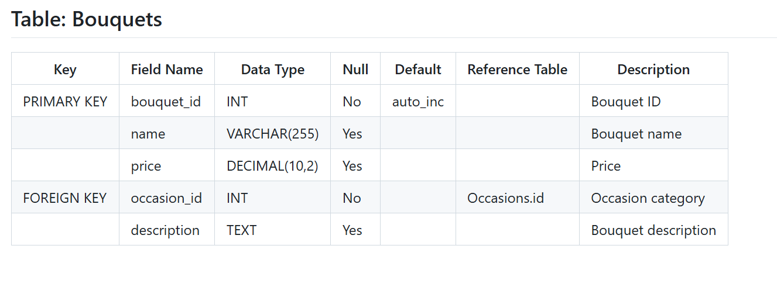

#### 2.7 Table: Bouquets_img

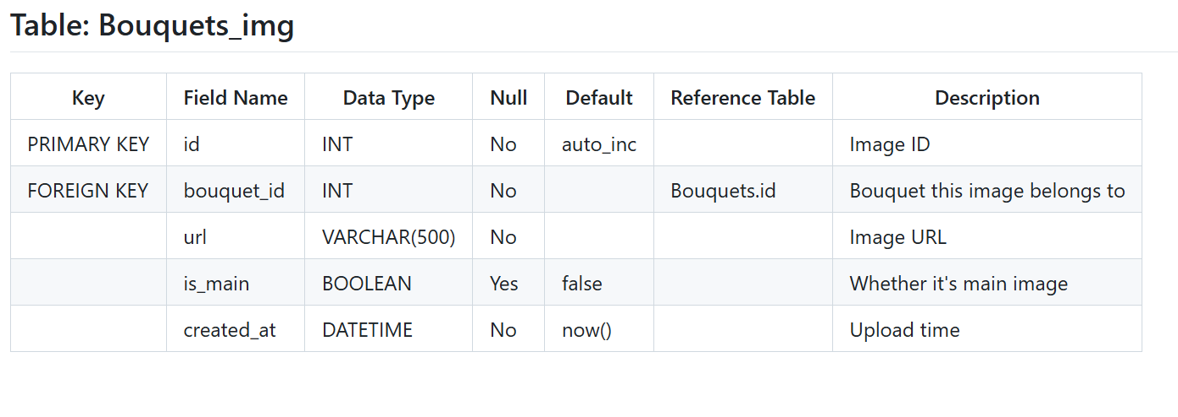

#### 2.8 Table: CartItems

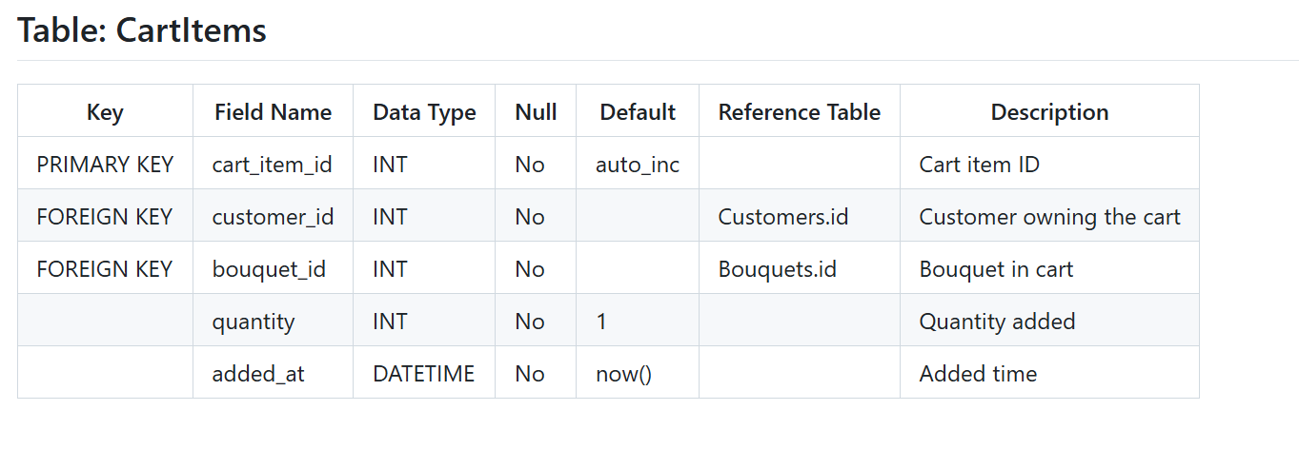

#### 2.9 Table: Orders

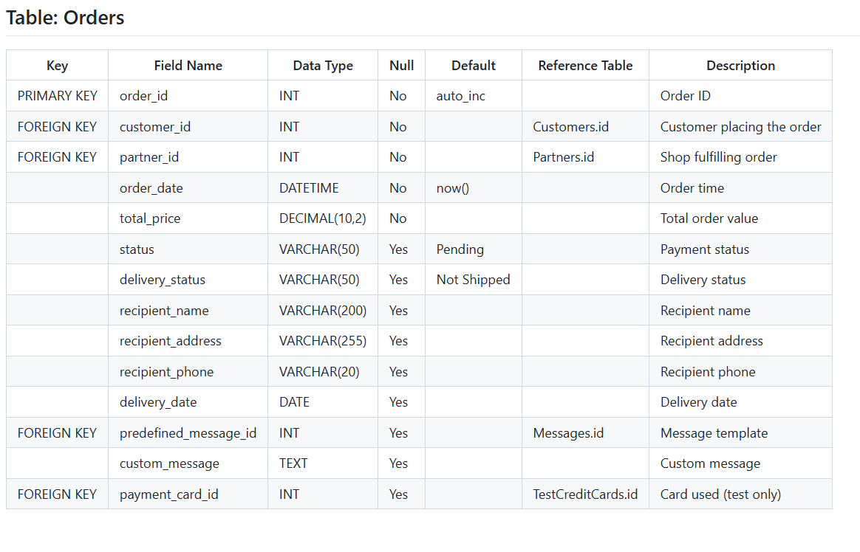

#### 2.10 Table: OrderDetails

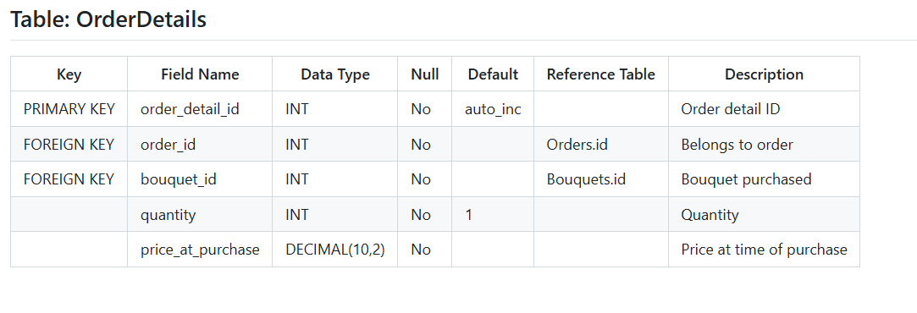

#### 2.11 Table: PayPalTransactions

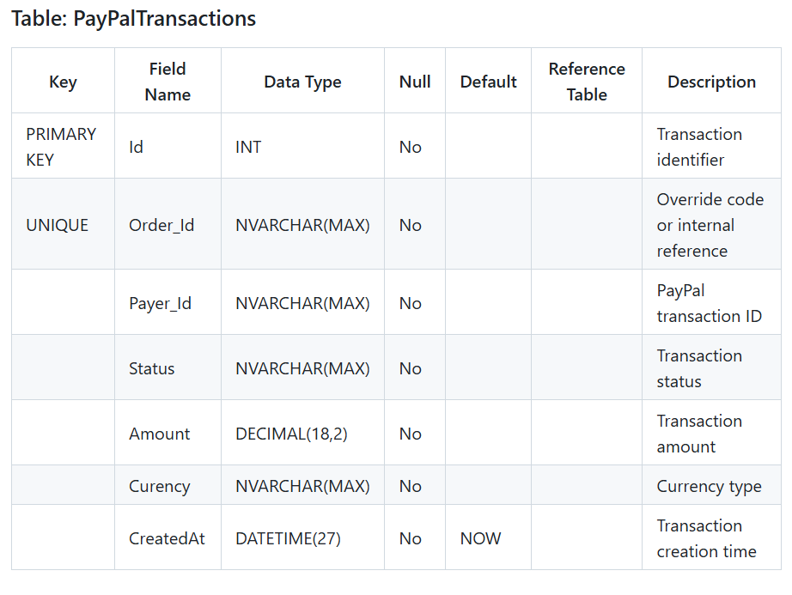

#### 2.12 Table: Payments

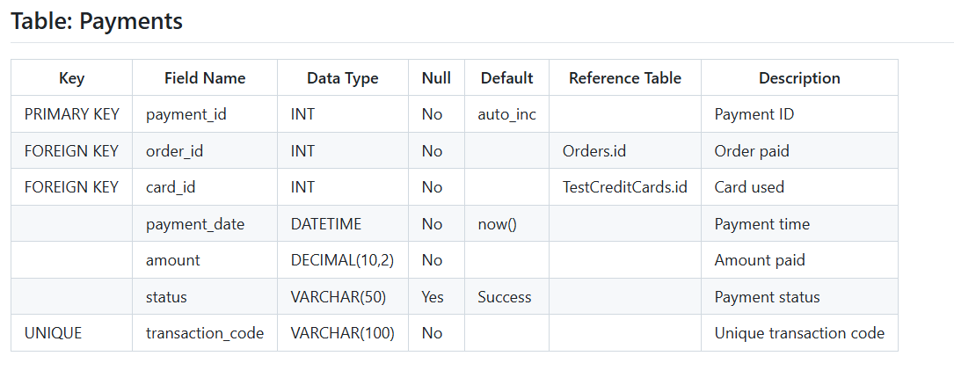

|  |  |  |  |  |  |  |  |
| --- | --- | --- | --- | --- | --- | --- | --- |
| **Project Ref. No.:**  **eP/Advertisement** **Portal Management** **System/01** | | **Project Title:** | **Activity Plan** **Prepared** **By:** | **Date of Preparation of Activity Plan:** | | | |
| **Sr.No.** | **Task** | **Actual Start** **Date** | **Actual** **Days** | **Team** **Mate** **Names** | **Status** |
| 1 | Architecture & Design of Project | Java florist | Dang Quoc Khanh | 17/11/2025 | 1 | All Member | Completed |
| 2 | Algorithms – Data Flowchart | 17/11/2025 | 3 | Khanh | Completed |
| 3 | Data Flow Diagram | 17/11/2025 | 3 | Thu | Completed |
| 4 | Use Case Diagram | 17/11/2025 | 3 | Loc | Completed |
| 5 | Entity-Relationship Diagram | 17/11/2025 | 3 | Huy | Completed |
| 6 | Task sheet review | 17/11/2025 | 1 | Trung Anh | Completed |

TASK SHEET REVIEW 2

|  |  |
| --- | --- |
| **Date: 17/11/2025** | |
| Signature of Instructor:  **Mr. Hoang Duc Quang** | Signature of Team Leader:  **Vu Thi Hoai Thu** |

**Source**

# REVIEW 3

## Technology

|  |  |  |
| --- | --- | --- |
| **No** | Component | Requirement |
| **1** | Front End | - React js  - JavaScript  - Jquery  - Bootstrap 5 |
| **2** | Back End | - Microsoft .NET Core Api 9.0  - Structure Query Language Server (SQL Server) |

## SiteMap

### User site map

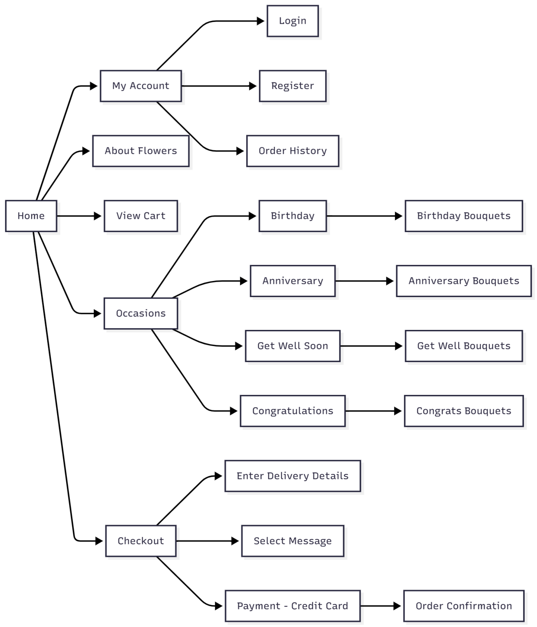

### Admin site map

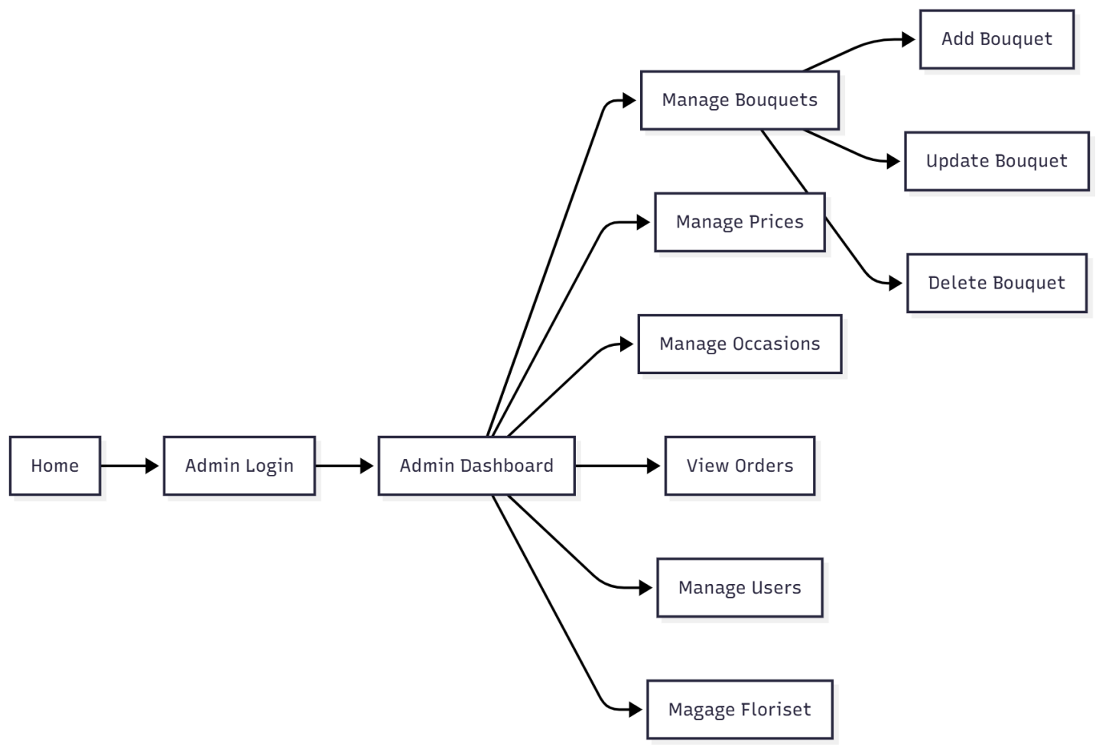

### Florist site map

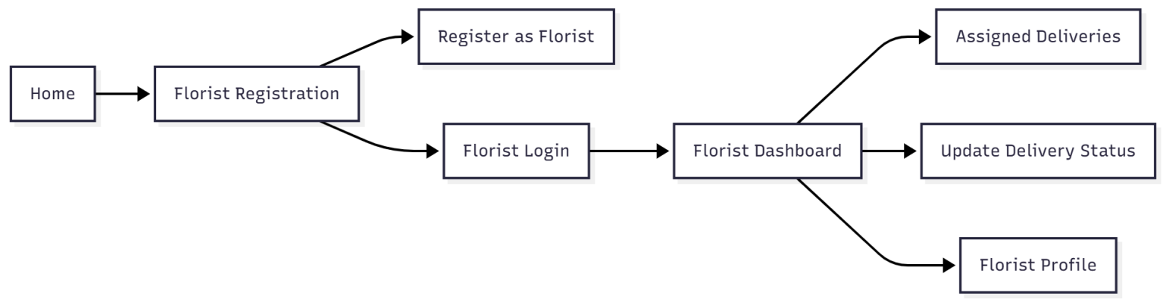

## Gui Design-User Interface

### User Interface

#### 1.1 Home Pagehome

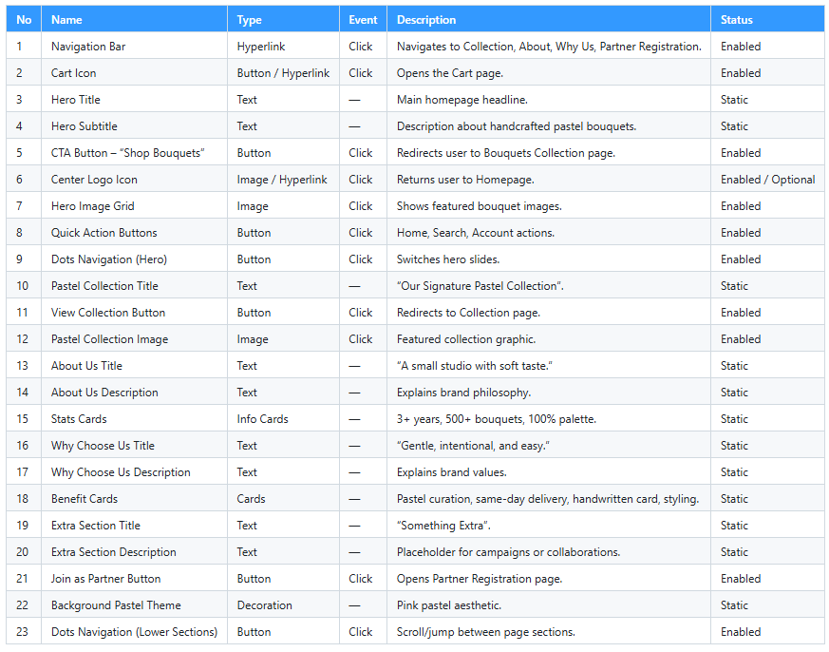

#### 1.2 Collection Page

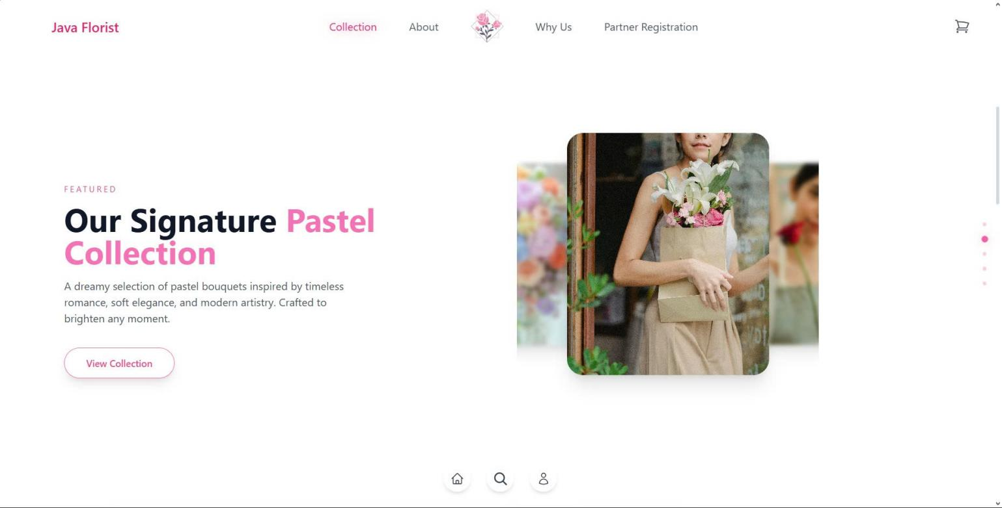

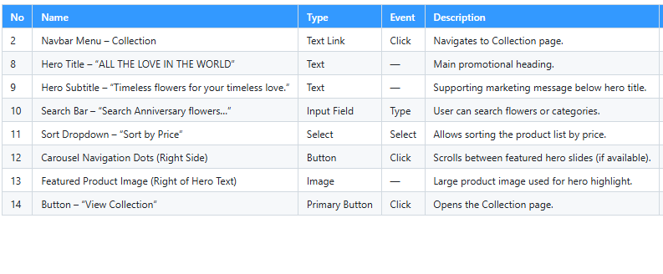

#### 1.3 About Page

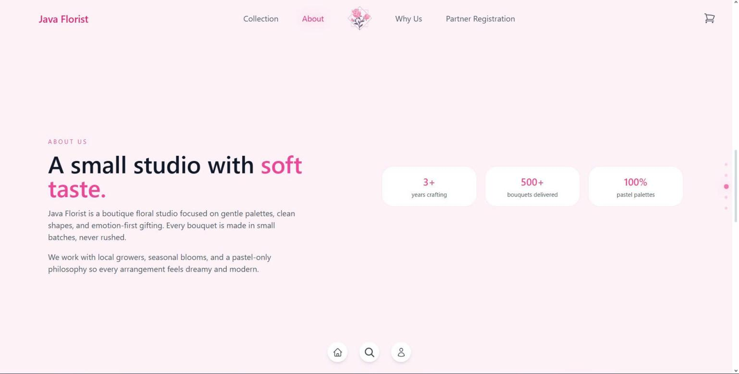

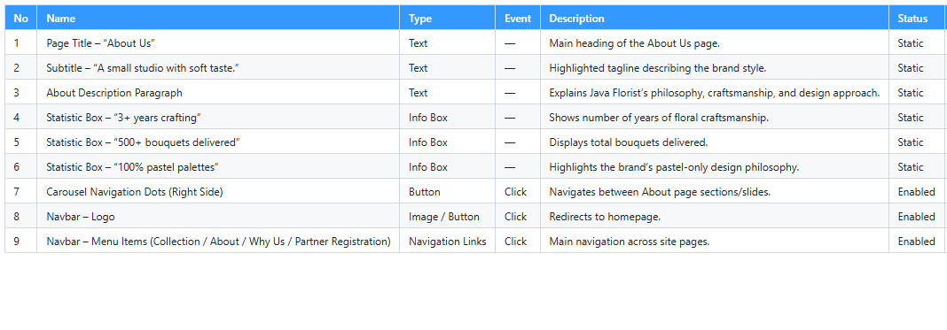

#### 1.4 Why Us Page

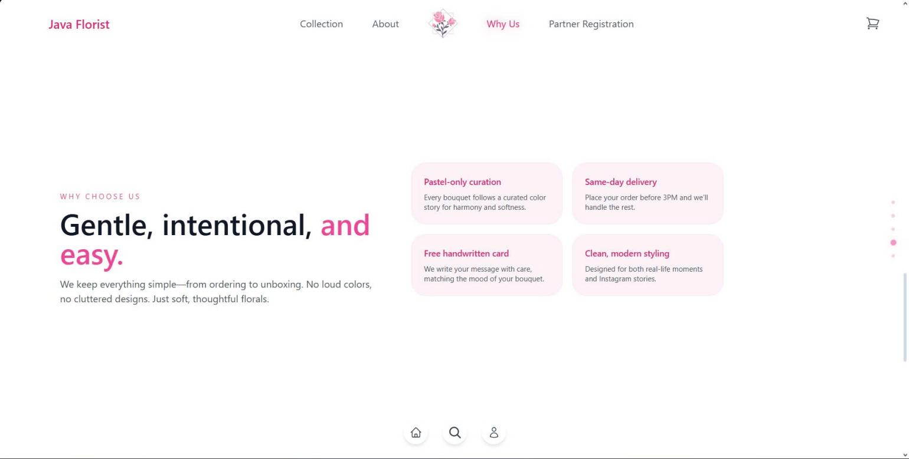

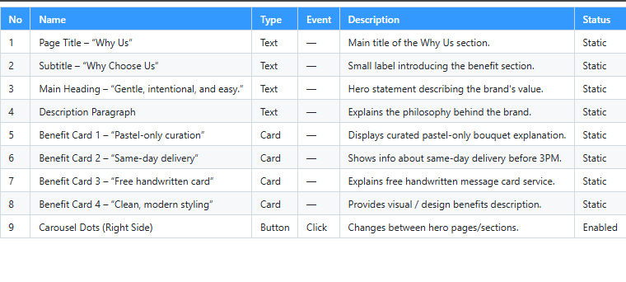

#### 1.5 Partner Registion Page

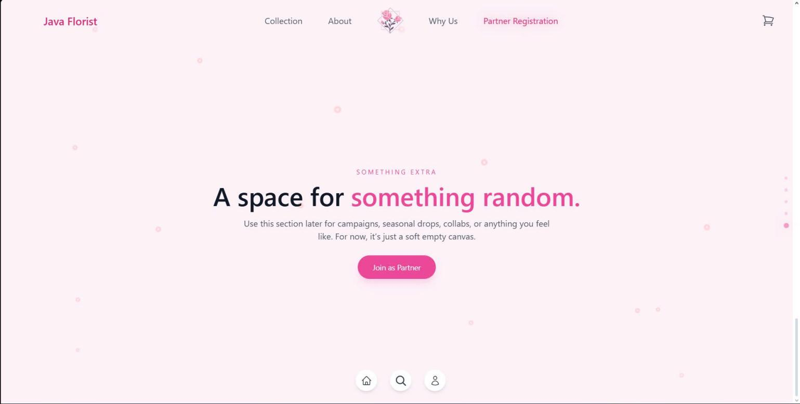

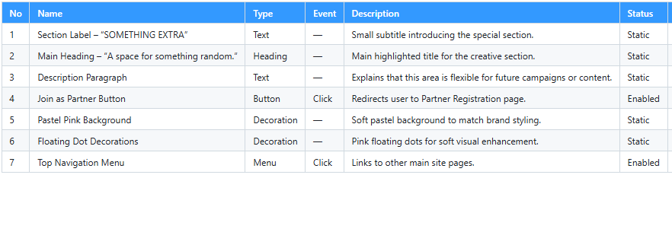

#### 1.6 Register Page

#### 

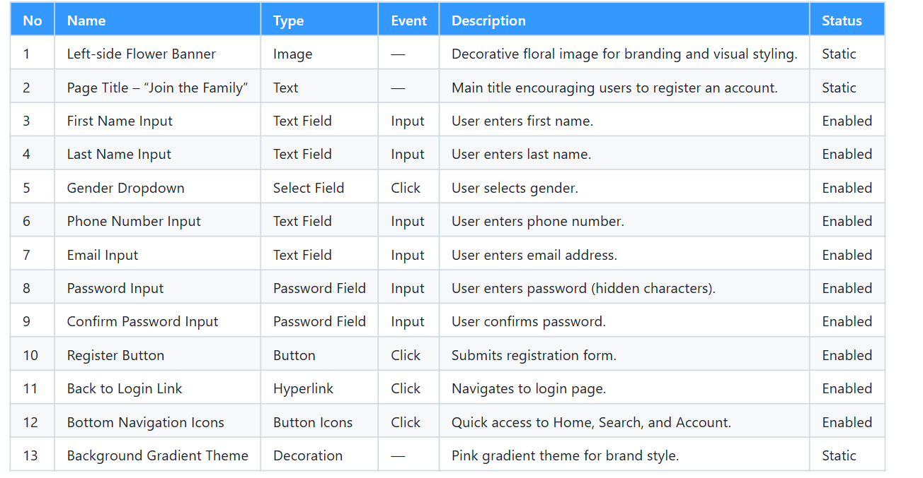

#### 1.7 Login Page

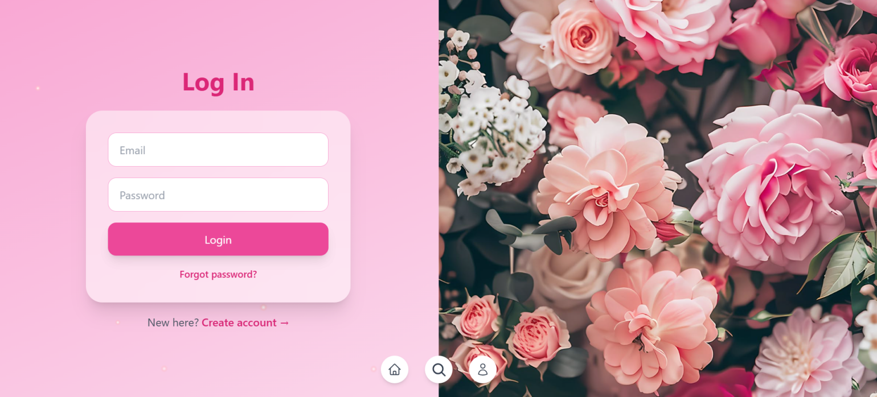

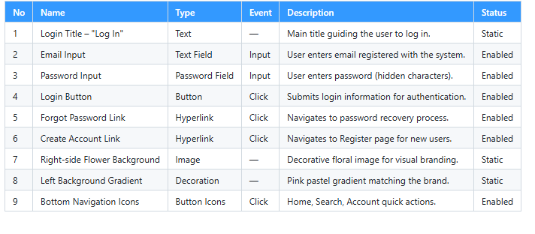

#### 1.8 My Acount Page

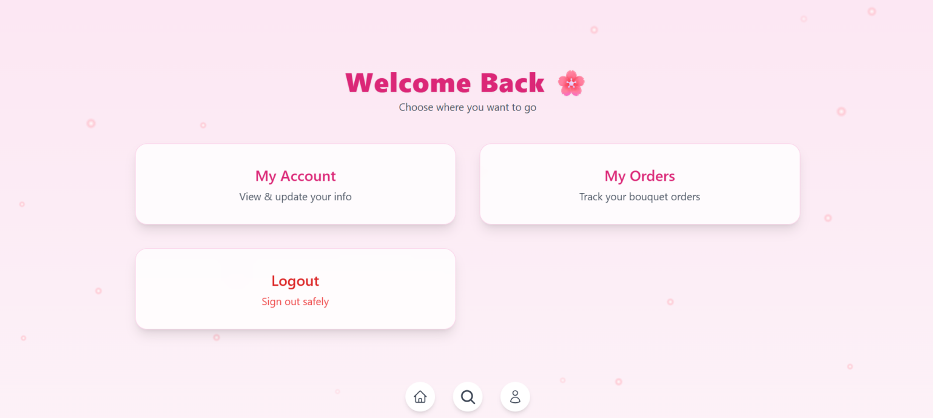

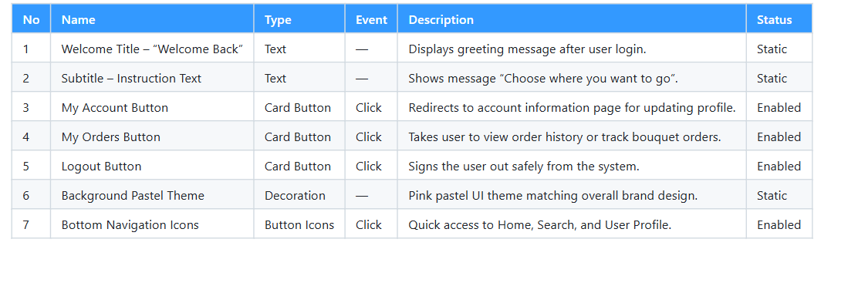

#### 1.9 Your Profile

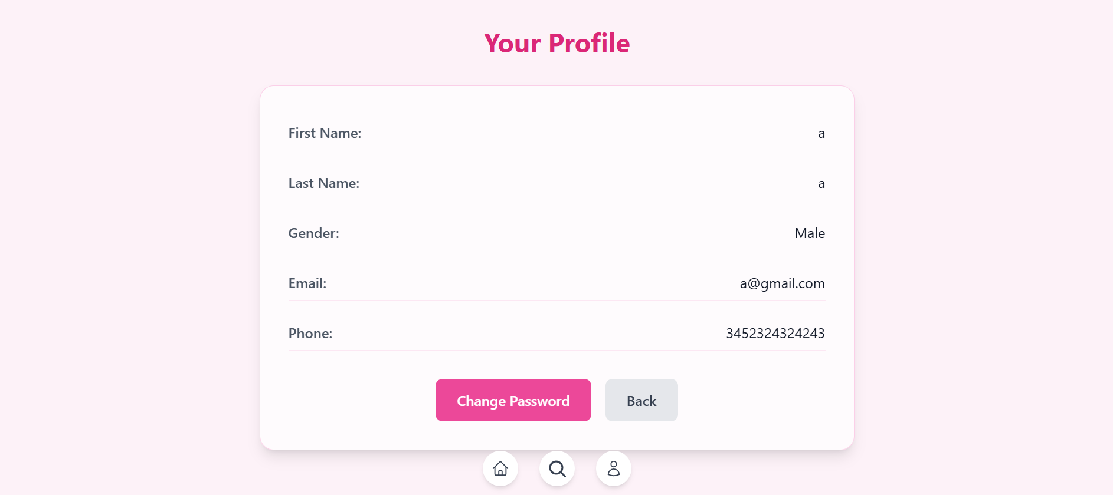

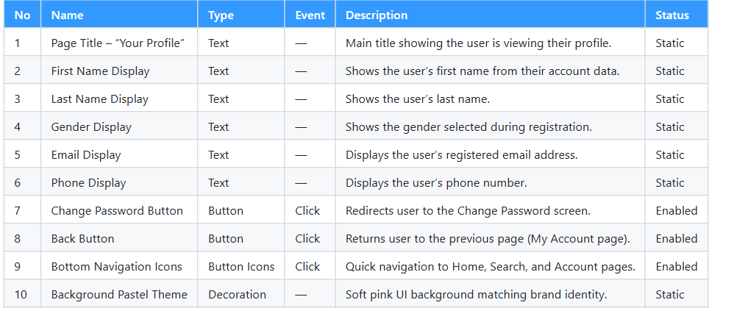

#### 1.10 Change Password

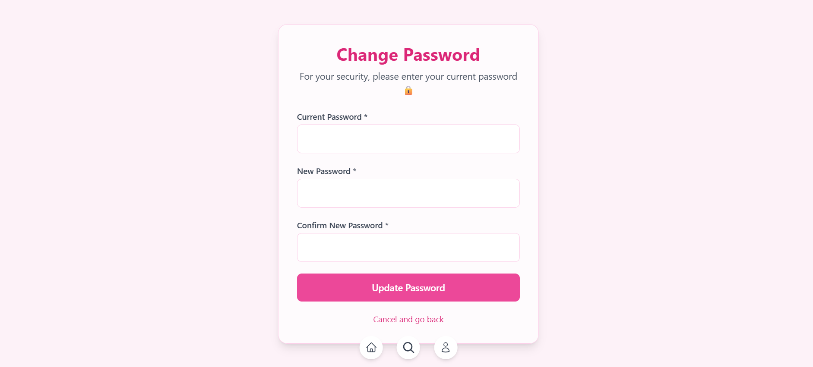

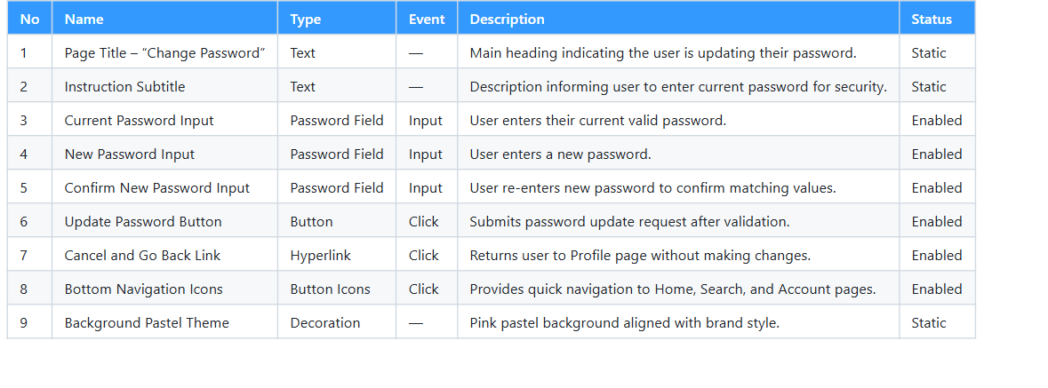

#### 1.11 All-products

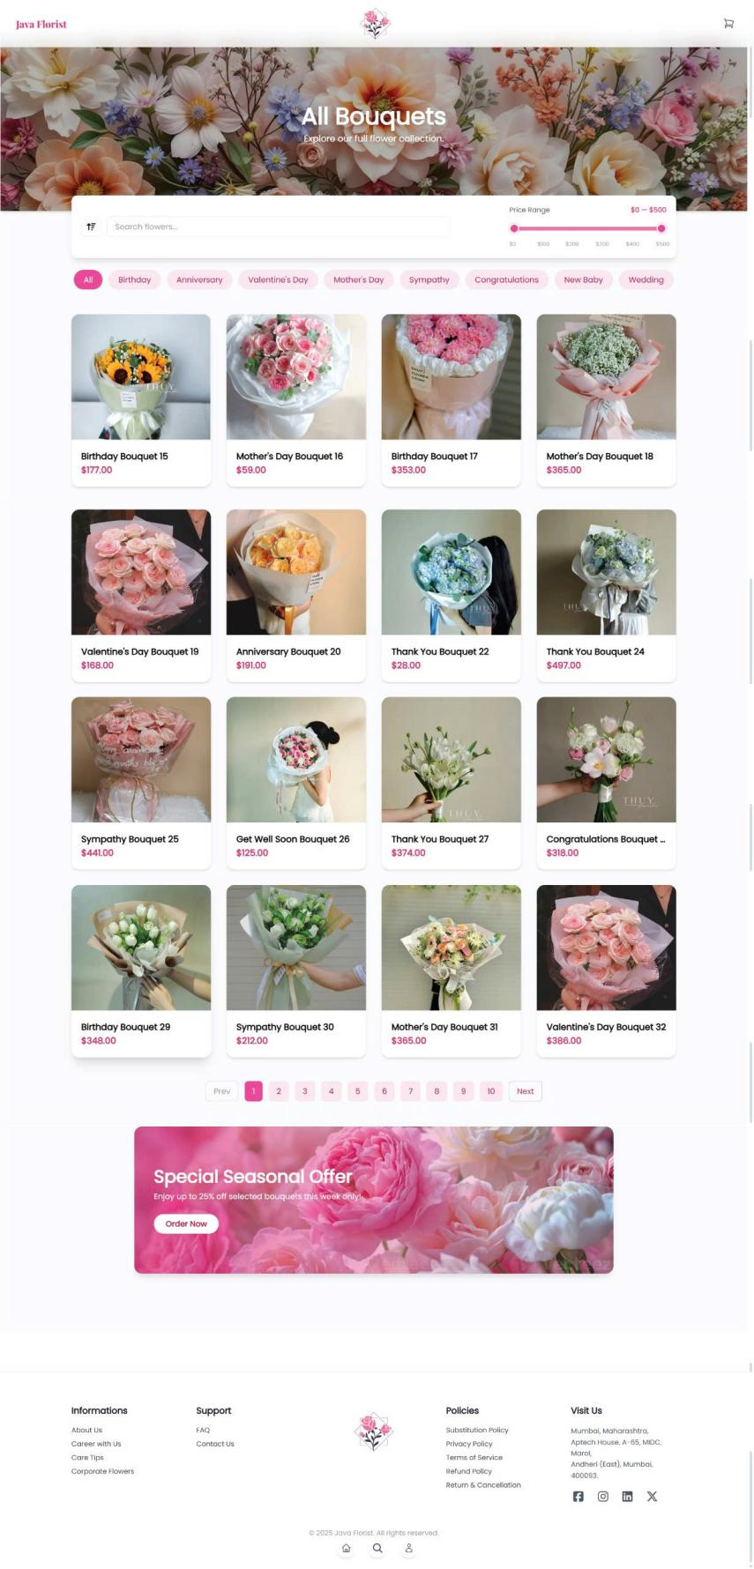

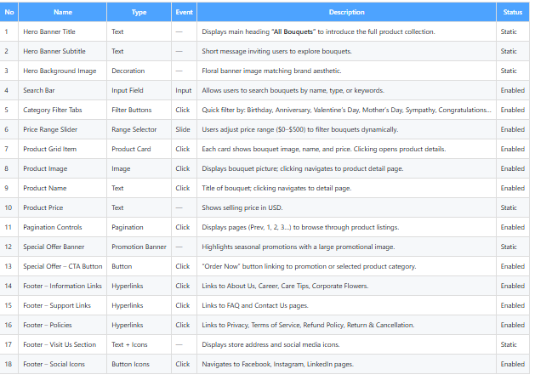

#### 1.13 Bouquet Detail Page

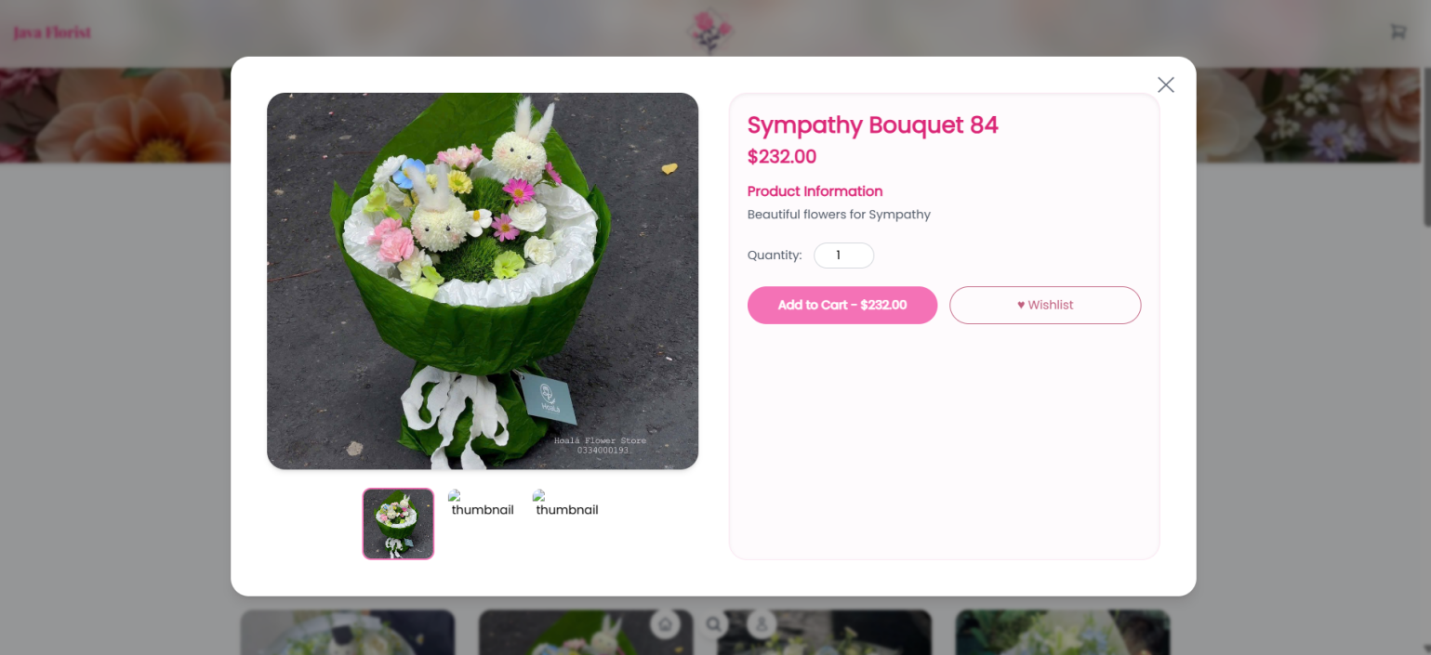

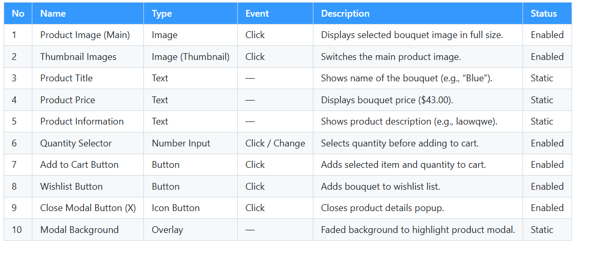

#### 1.14 Card Page

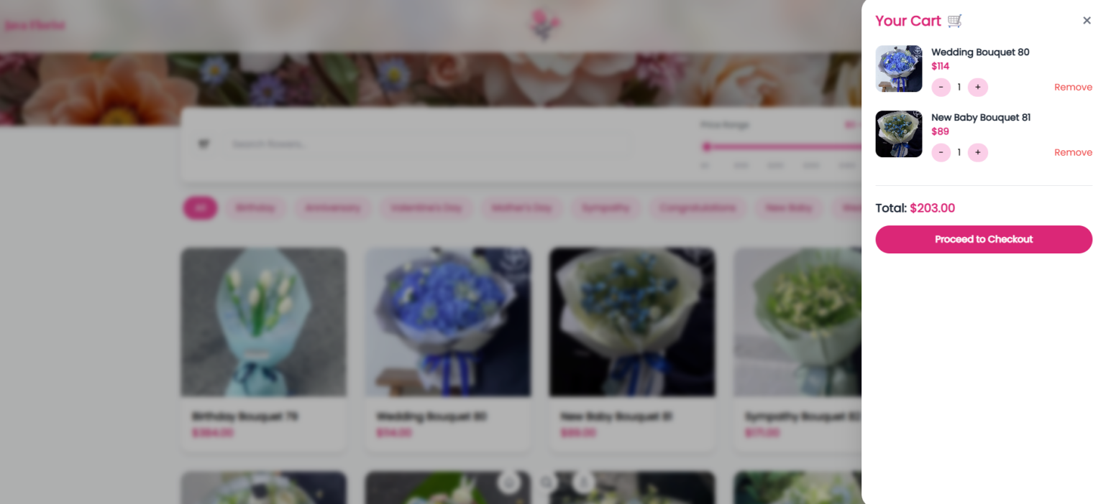

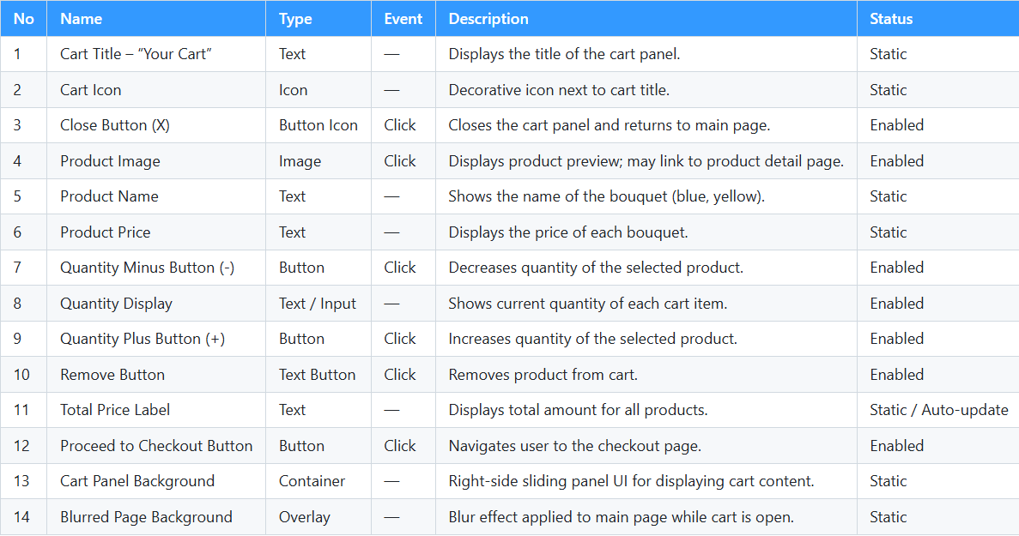

#### 1.15 Check Out Page

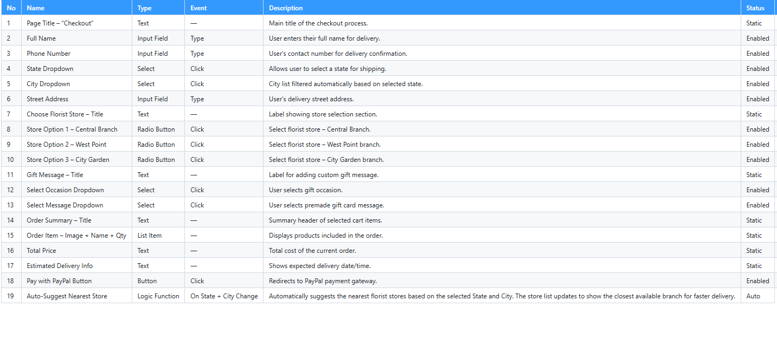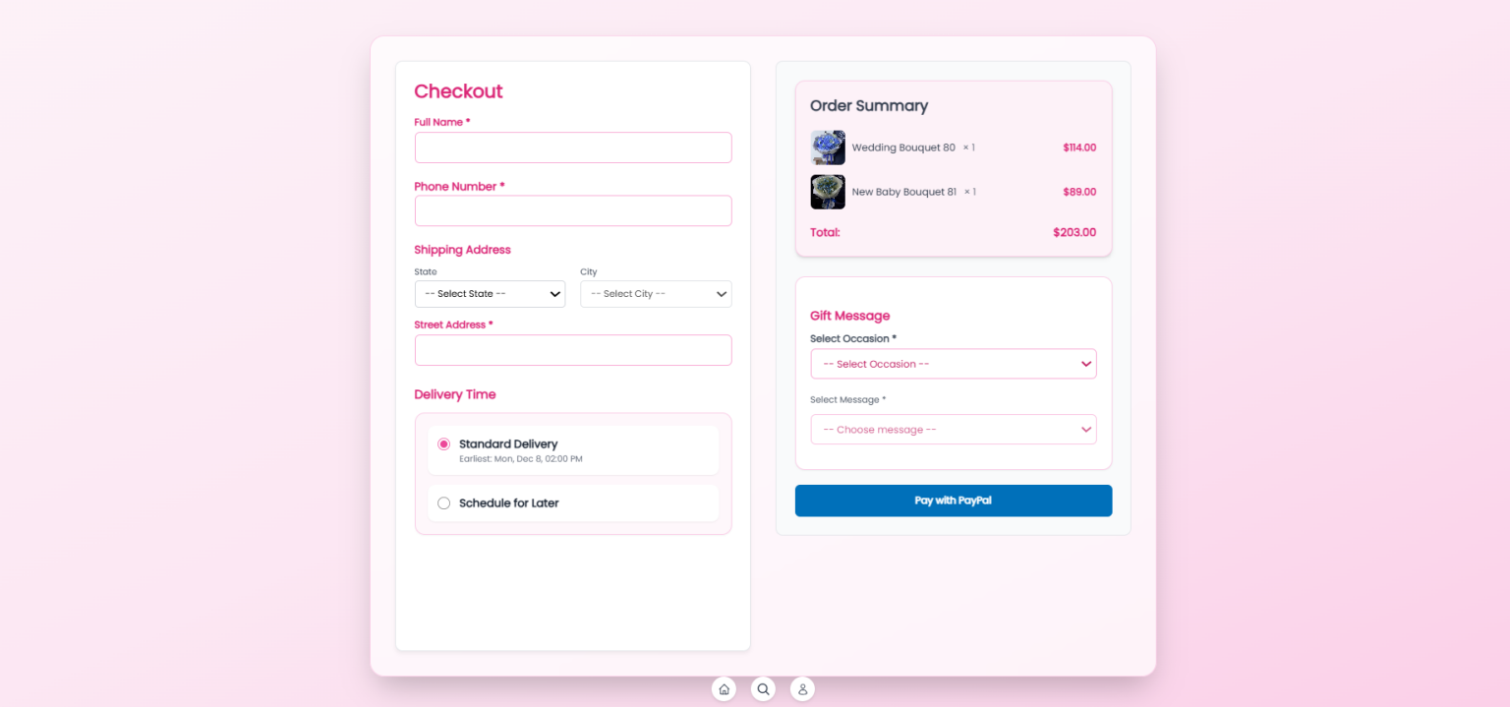

#### 1.16 PayPal Page

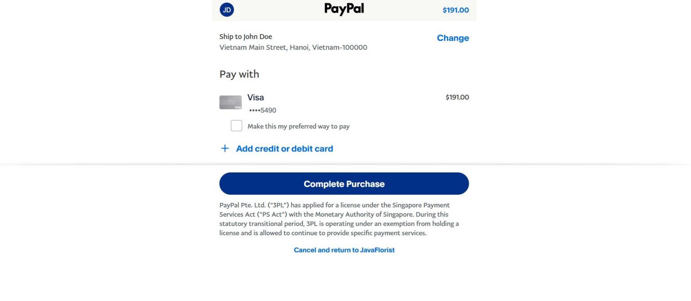

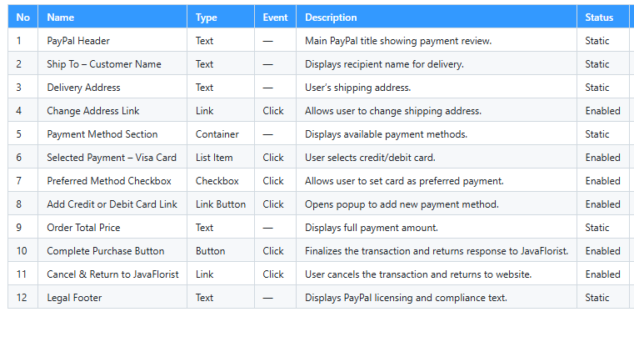

#### 

#### 1.17 My Order Page

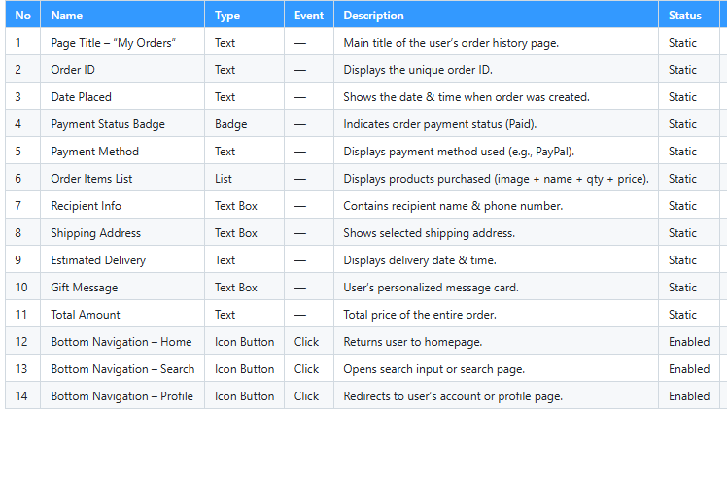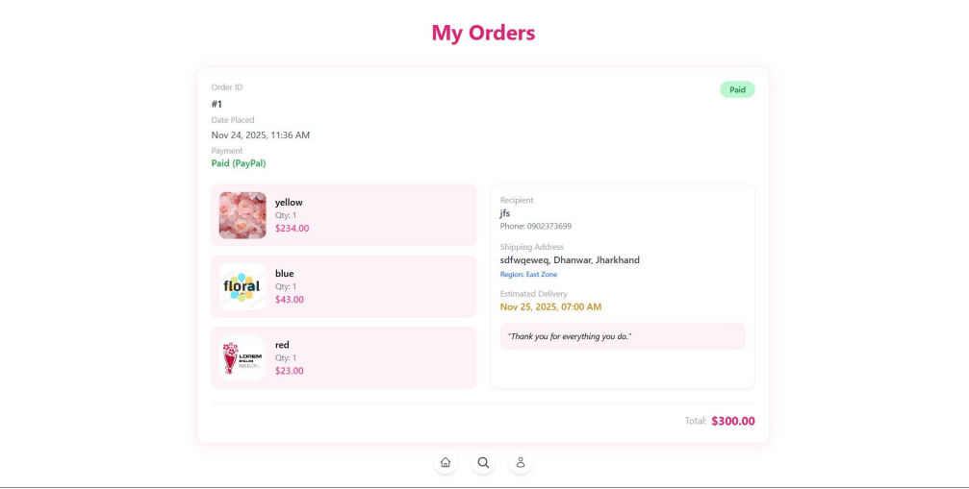

#### 

#### 1.18 Your profile

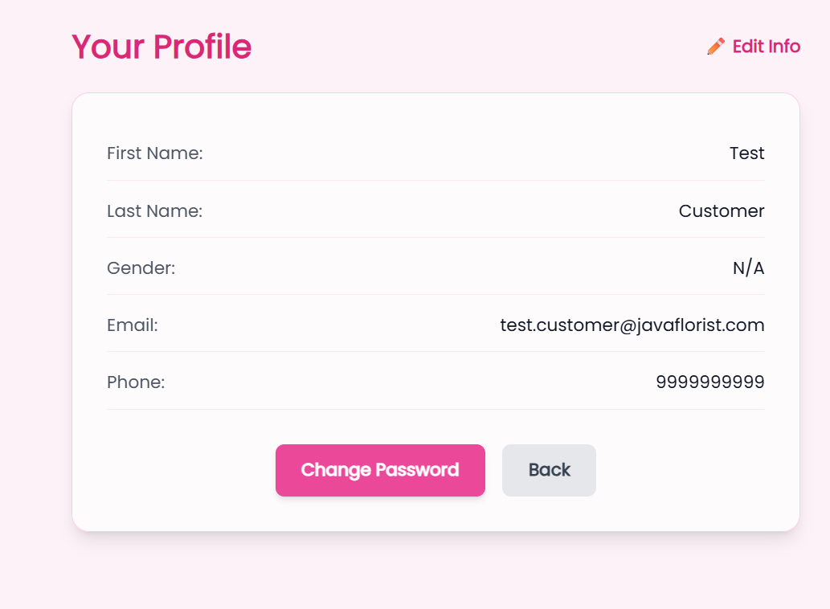

#### 

#### 1.19 User change password

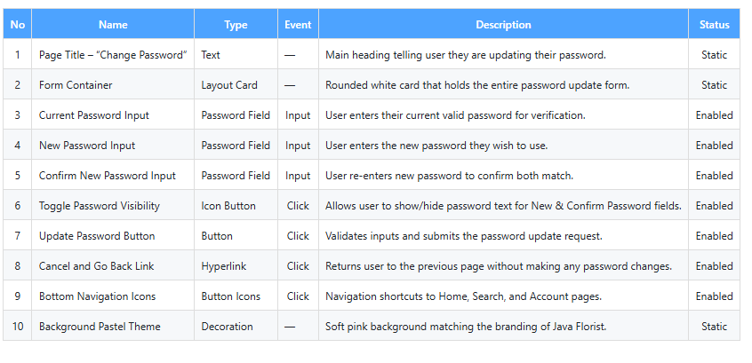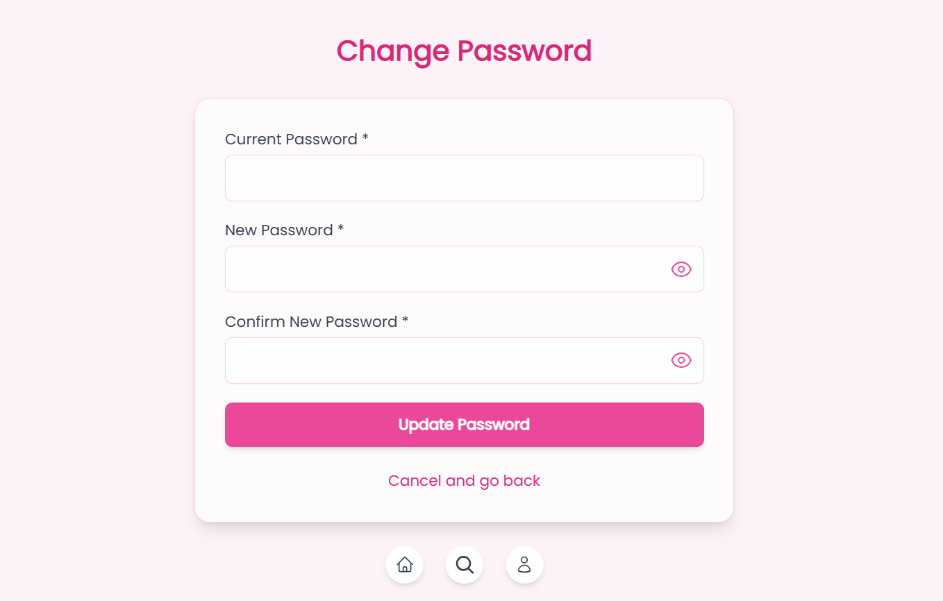

### Partner

#### 2.1 Partner Registration

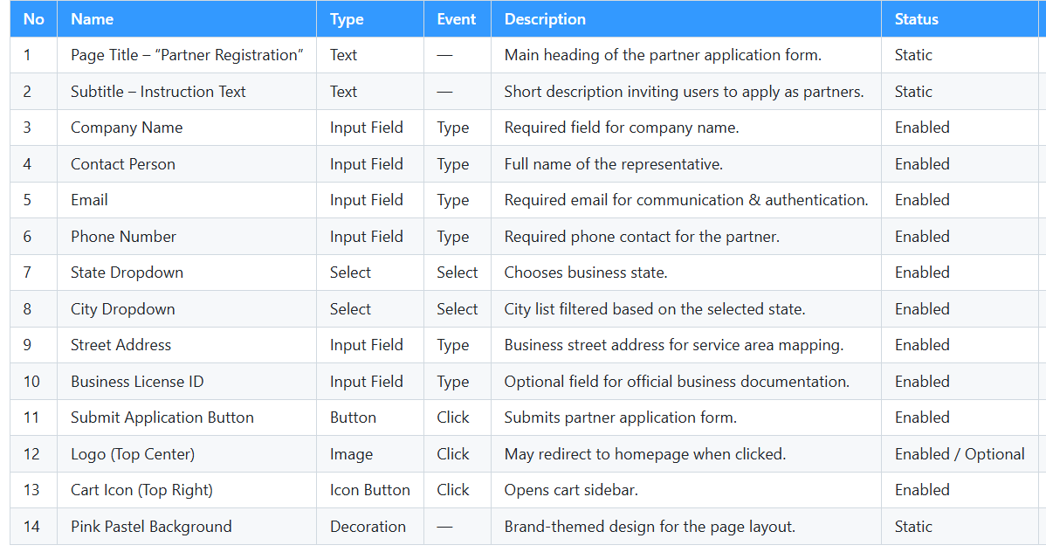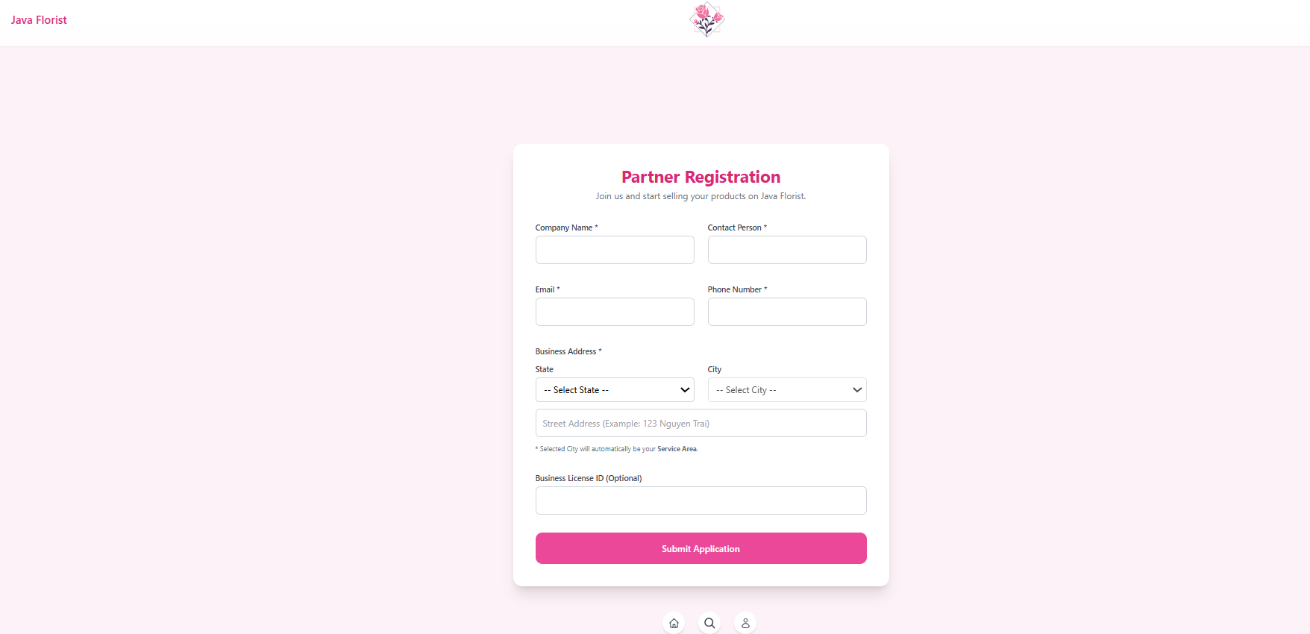

#### 2.2 Parter page

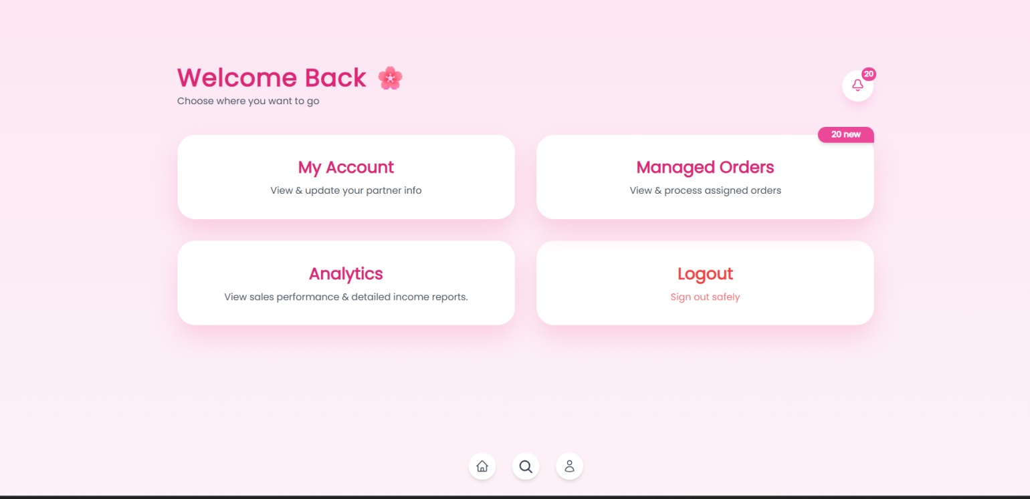

#### 

#### 2.3 Parter Profile

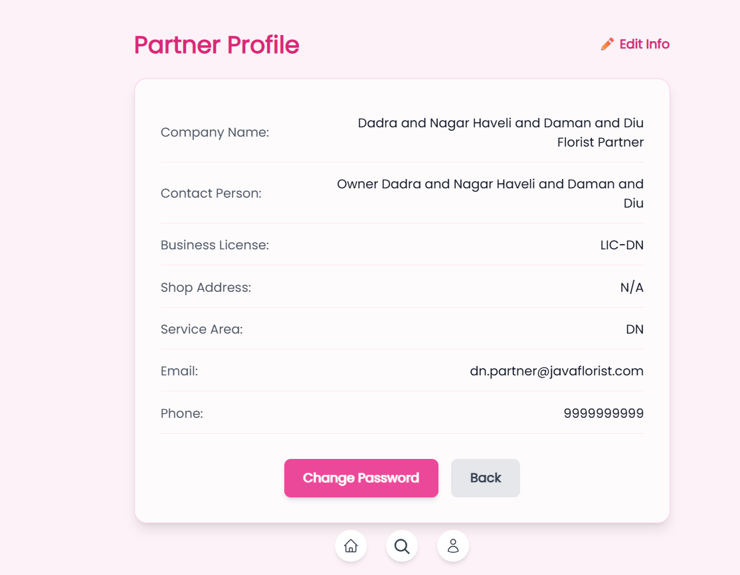

#### 

#### 2.4 Partner Order Management

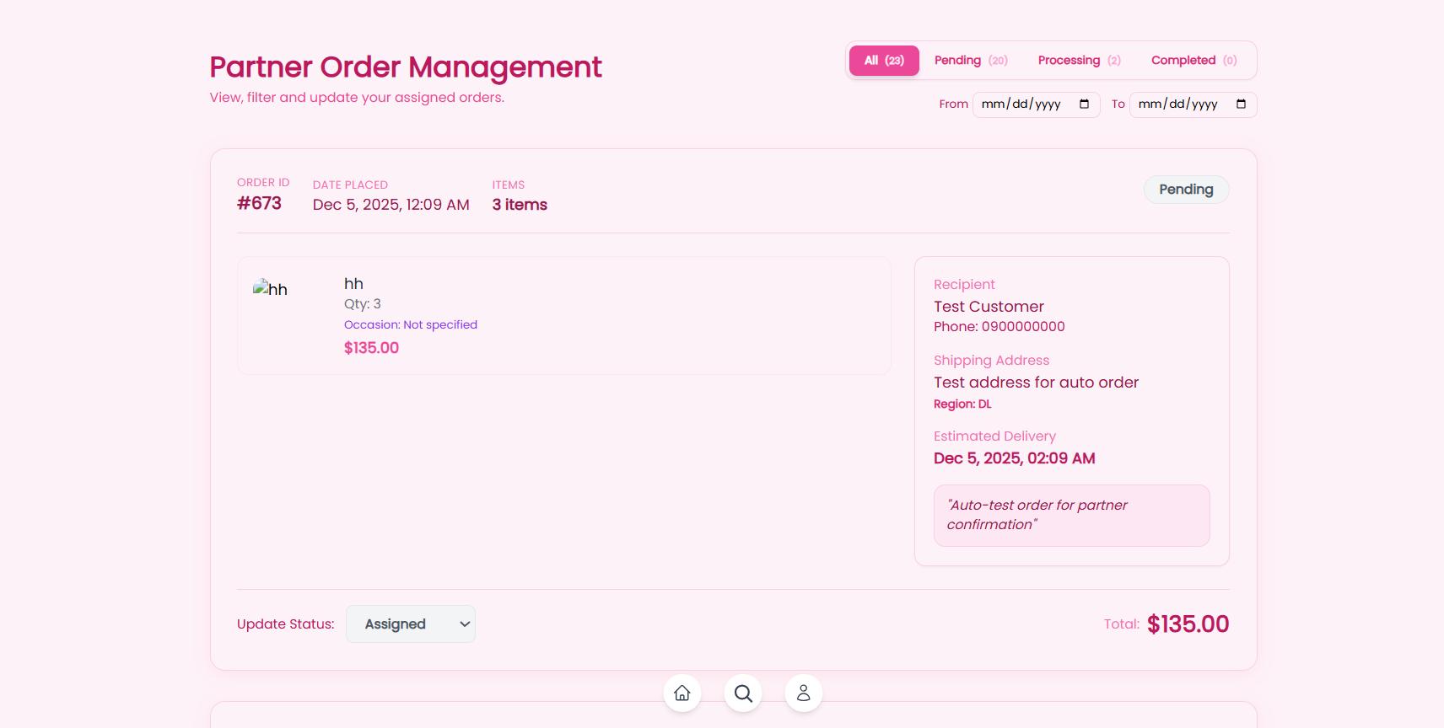

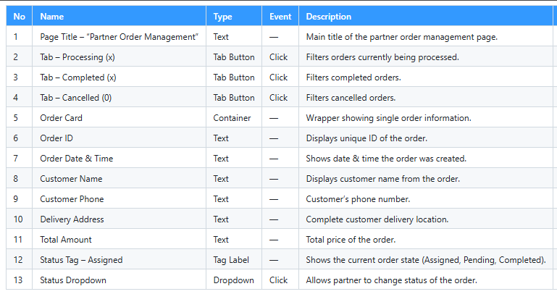

#### 2.5 Partner Analytics & Income

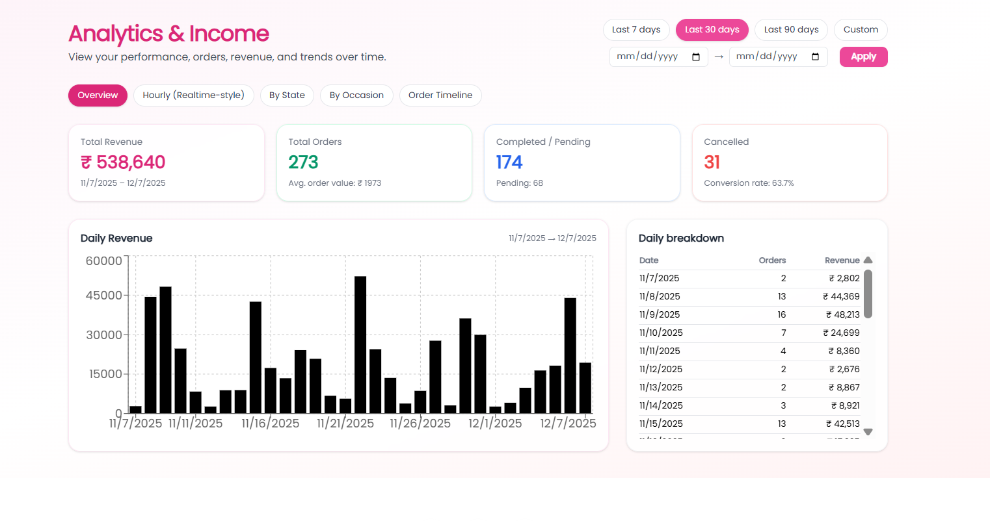

### Admin Page

## 

#### 3.1 User Management

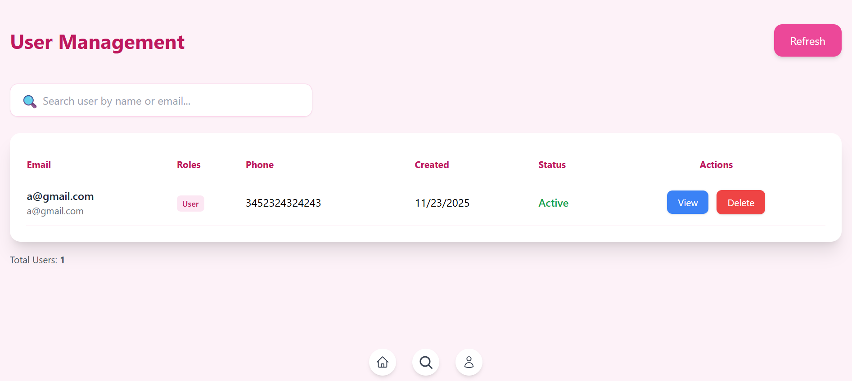

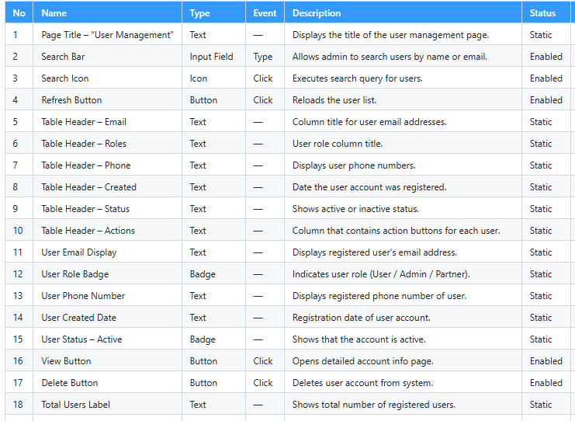

#### 3.2 Bouquet Management

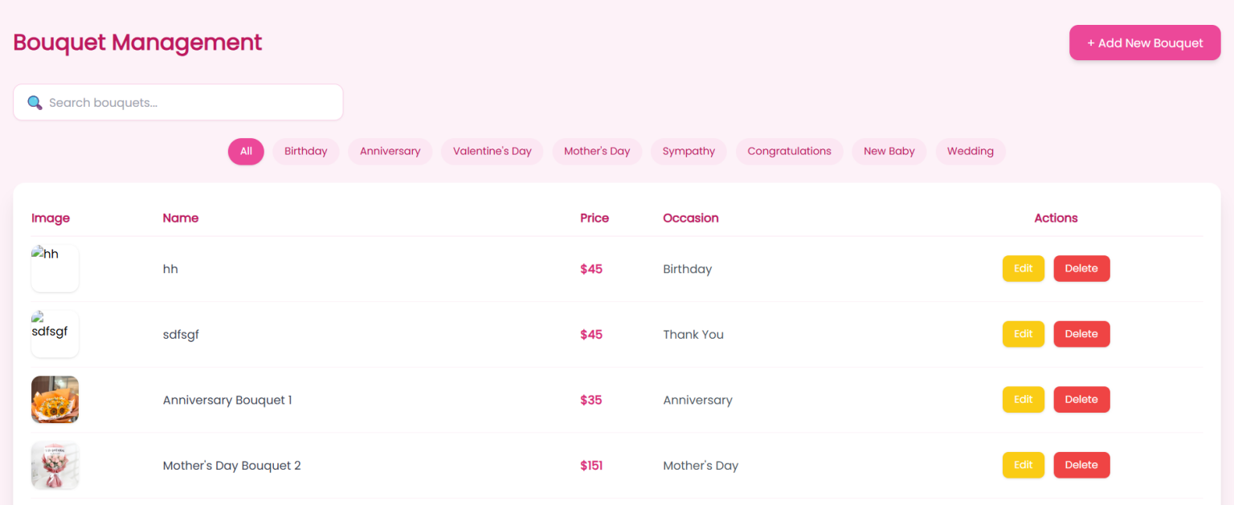

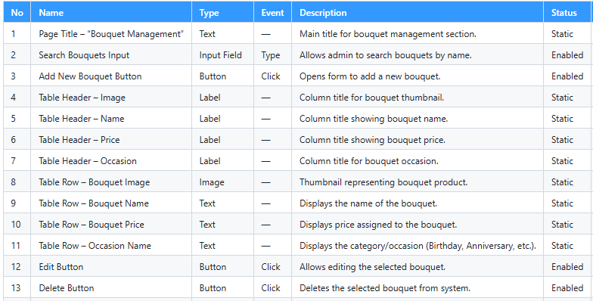

#### 3.3 Pending Partner Applications

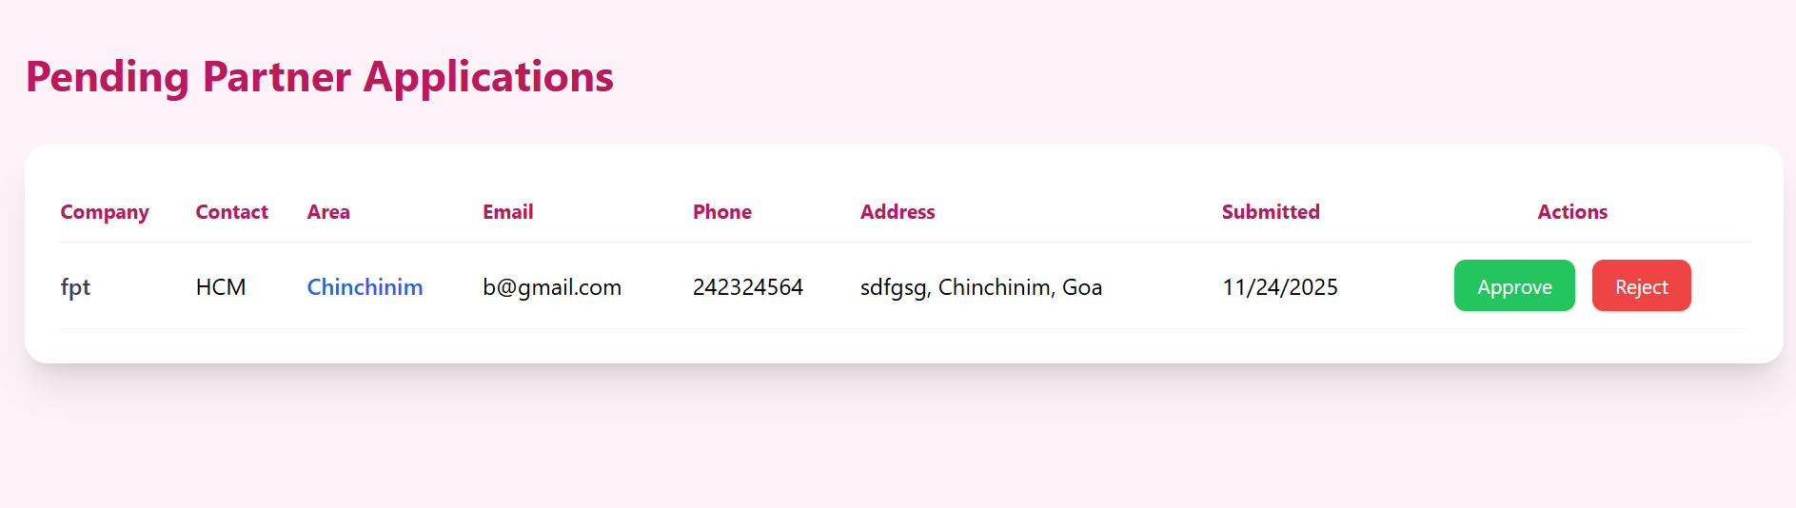

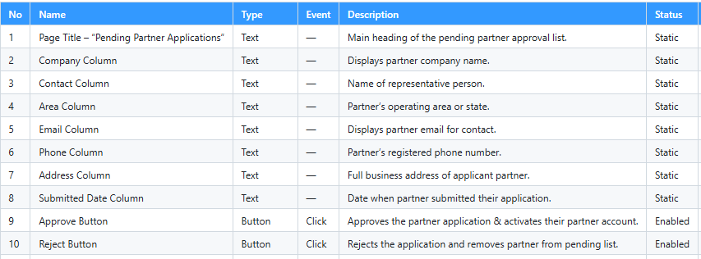

#### 3.5 Admin Order Management

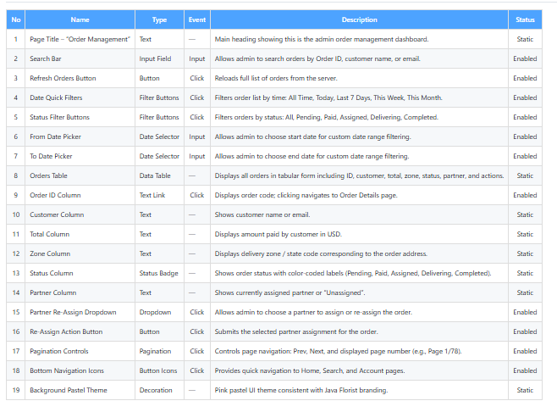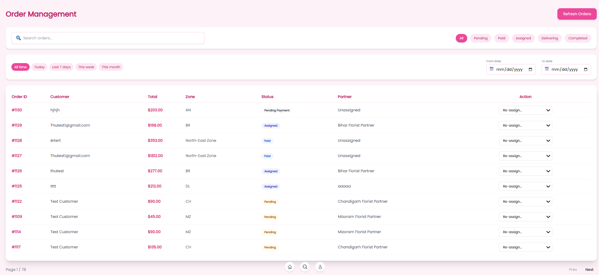

#### 

#### 3.6 Admin Order Management Detaile

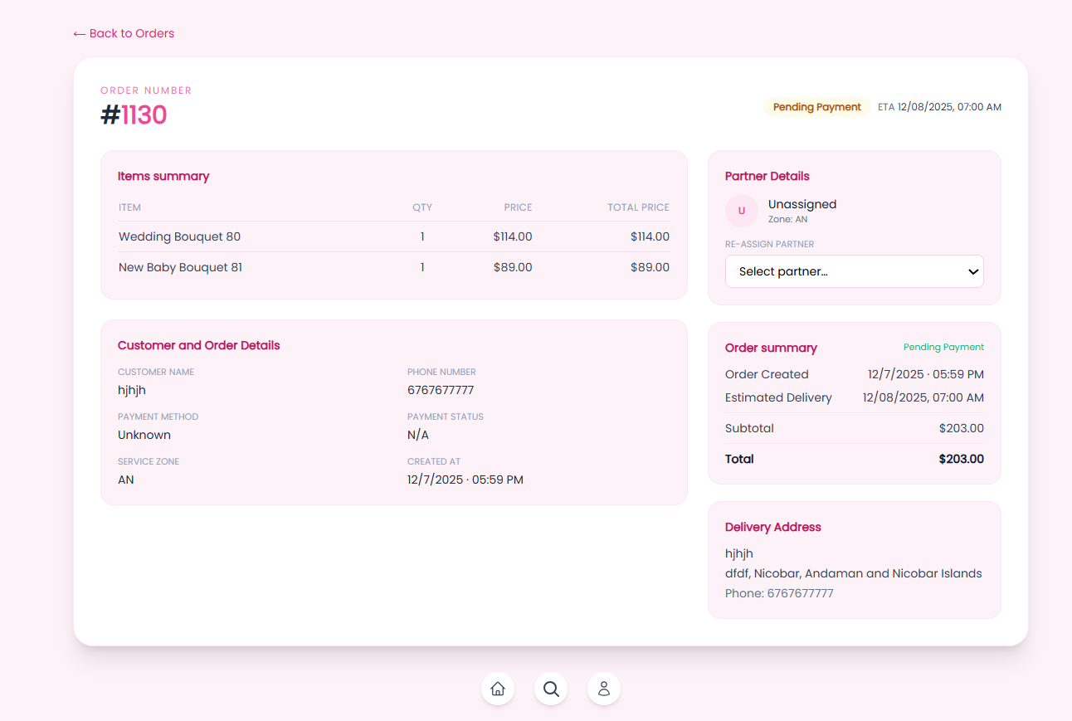

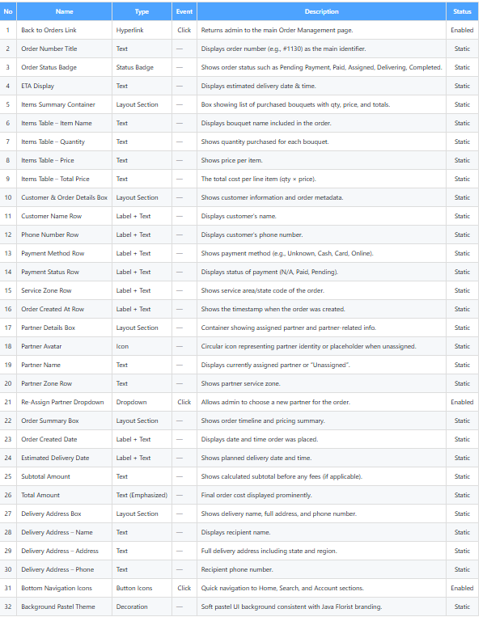

TASK SHEET REVIEW 3

|  |  |  |  |  |  |  |  |
| --- | --- | --- | --- | --- | --- | --- | --- |
| **Project Ref. No.:**  **eP/Advertisement** **Portal Management** **System/01** | | **Project Title:** | **Activity Plan** **Prepared** **By:** | **Date of Preparation of Activity Plan:** | | | |
| **No.** | **Task** | **Actual Start** **Date** | **Actual** **Days** | **Team** **Mate** **Names** | **Status** |
| **1** | Database Design | Java-Florist | Thu | **11/8/2025** | **2** | **T.Anh** | Completed |
| **2** | ERD, DFD Design | **11/09/2025** | **1** | **Thu** | Completed |
| **3** | SQL Table Creation ( PK, FK, Index) | **11/10/2025** | **1** | **T.Anh, Thu** | Completed |
| 4 | Home page | 11/10/2025 | 1 | Khanh, Thu | Completed |
| 5 | Login – User - Role | 11/11/2025 | 2 | Huy | Completed |
| 5 | Occasion – Bouquet List Page | 11/13/2025 | 1 | Khanh | Completed |
| 6 | Bouquet Detail Page | 11/14/2025 | 1 | Khanh, Huy | Completed |
| 7 | Shopping Cart | 11/15/2025 | 1 | T.Anh | Completed |
| 8 | Checkout – PayPal - Procedure | 11/16/2025 | 4 | T.Anh | Completed |
| 9 | Dynamic Dropdown: State → City → Area | 11/19/2025 | 3 | Huy, Loc | Completed |
| 10 | Occasion-Based Message Templates | 11/22/2025 | 1 | Loc | Completed |
| 11 | Delivery Logic (5 hour rule) | 11/23/2025 | 1 | Huy, Loc | Completed |
| 12 | Bouquets API (CRUD) | 11/24/2025 | 1 | Huy | Completed |
| 13 | Occasions & Messages API | 11/25/2025 | 1 | Huy | Completed |
| 14 | Order API | 11/26/2025 | 1 | Huy, Loc | Completed |
| 15 | Documentation (SRS + Final Report) | 11/27/2025 | 1 | Thu | Completed |
| 15 | API Testing | 11/28/2025 | 4 | Huy, T.Anh | Completed |
| 16 | Fontend UI Testing | 12/02/2025 | 4 | Khanh, Loc, Thu | Completed |
| 17 | Integration Testing | 12/06/2025 | 3 | All Members | Completed |